A Research Project Stage-II Report on

Explaining Condition-Based Maintenance for Metro Trains Using Ensemble ML with XAI and Hybrid Deep Learning Models

By

Aniket Singh
(Roll No: PA 06 PRN: 1032233536)

Guide
Dr. Sarika Bobde


Department of Computer Engineering and Technology
Dr. Vishwanath Karad
MIT World Peace University, Pune.
[Academic Year 2024-25]


DEPARTMENT OF COMPUTER ENGINEERING AND TECHNOLOGY

C E R T I F I C A T E

This is to certify that Mr. Aniket Singh, Seat No.1032233536 has successfully completed his Research Project Stage-II (Code: CSD8PR04A) entitled “Explaining Condition-Based Maintenance for Metro Trains Using Ensemble ML with XAI and Hybrid Deep Learning Models” under my supervision and submitted the same during the academic year 2024-25 towards the partial fulfilment of degree of Master of Technology in Computer Science and Engineering (CSE) with Specialization in Data Science & Analytics (DSA) of Dr. Vishwanath Karad MIT World Peace University, Pune.
Date:

Place:

Dr. Sarika Bobde  Guide, DoCET |  | Dr. B. M. Patil  Program Director, DoCET
 | Seal
External Examiner |  | Dr. Prasad Khandekar  Officiating Dean, SoCSE  MIT WPU, Pune

Certificate of completion by Company
(On Company Letter-head)

Abstract

Metro train systems are essential for urban transport, yet they face increasing risks of operational failures that can interrupt services and jeopardize passenger safety. To maintain their dependability, it is crucial to implement effective methods for classifying failures and estimating the remaining useful life (RUL). However, current methodologies faces many challenges, such as imbalanced datasets, high computational demands, reliance on synthetic data, difficulties in handling large time-series data, improving interpretability using explainable AI (XAI), and overfitting.
To solve these problems, this study proposes a comprehensive framework that use ensemble machine learning techniques, including Stacking, Random Forest, Bagging, and XGBoost, along with modern hybrid deep learning models like TCN-GRU, which combines the extraction of temporal features which is strengths of Temporal Convolutional Networks (TCNs) with the well organized sequential modeling capabilities of Gated Recurrent Units (GRUs). Also, we are using resampling technique, such as down-sampling for large time-series datasets, to retain over 90% of the original data's variance, considerably reduces computational demands. Explainable AI (XAI) tools like SHAP and LIME was integrated only to the ensemble methods to provide both global and local interpretations.
Our proposed framework was evaluated using a real-world dataset from metro train sensors data, focusing on the Air Production Unit (APU) because of it’s important functions in train braking and door operations. Our results shows that the Stacking ensemble model overcome other models in failure classification, getting 99.95% on all evaluation metrics, while the hybrid TCN-GRU model surpassed in RUL prediction with an R²-score around 0.92 as well as 0.26 RMSE. Also, our findings show that using SHAP provides an global view of how important features influence model predictions, which helps us plan maintenance tasks more effectively. Analyzing the SHAP plots helped us identify which important features effects the failure predictions and also giving a useful thresholds (like oil temperature over 70 °C or pressure above 8 bar) that maintenance teams can use to set priorities for early interventions.
Our research shows that using ensemble and hybrid models can strengthen predictive maintenance for public transport. This method has clear advantages, including cost savings, greater reliability, better performance, and improved safety. Future work will focus on extending these techniques to other important systems and industries, aiming for real-time use and adaptive learning to make them even more widely applicable.

Keywords – Predictive maintenance, Condition-based maintenance, metro trains, ensemble machine learning, hybrid deep learning, TCN-GRU model, Explainable AI, failure classification, remaining useful life estimation.

Acknowledgement

It gives me great pleasure to present a Project Stage-II report on “Explaining Condition-Based Maintenance for Metro Trains Using Ensemble ML with XAI and Hybrid Deep Learning Models". In preparing this report number of hands helped me directly and indirectly. Therefore, it becomes my duty to express my gratitude towards them.
I express my heartfelt gratitude to my project guide, Dr Sarika Bobde for their invaluable guidance, constant encouragement, and expert insights throughout the course of my M.Tech dissertation. Their mentorship and constructive feedback have been pivotal in shaping this research and enhancing my understanding of the subject.

Additionally, I extend my sincere appreciation to all the expert panel members Dr. Preeti Kale, Dr. Aditi Jahagirdar, and Prof. Madhura Phatak for their expert guidance, insightful suggestions regarding the project.

I would also like to thank all the faculty members and staff of the Department of Computer Engineering and Technology at Dr. Vishwanath Karad MIT World Peace University, Pune, for providing the necessary academic environment, resources, and technical support.

Their help and cooperation have played a vital role in shaping this project, and I sincerely appreciate their contributions.
My acknowledgement would be incomplete without saying thanks to the greatest wellspring of my quality, my family. The blessings of my parents Mrs. Poonam singh and Mr. Dilip singh have all made a huge commitment in helping me achieve this phase in my life. This would not have been conceivable without their unflinching and unselfish love and support given to me consistently.

Contents
Ch. No. | Name of Sections | Page No.
 | Certificate  Certificate Of Completion By Company  Abstract  Acknowledgement  Contents  List of Figure  List of Tables  Nomenclature  Abbreviations | I  II  III  V  VI  VIII  IX  X  XI
1. | Introduction  - Background of the Project  - Organization of report | 1  1  7
2. | Literature Survey  - Basis of literature Review  - Literature  - Summary of literature  - Research Gap | 8  8  8  16  18
3. | Aim, Objectives and Scope of study  - Aim  - SCOPE  - Objective | 19  19  19  19
4. | Methodology  - Data Collection  - Data Preprocessing  - Feature Engineering  - Ensemble Machine Learning Models  - Deep Learning Models and Hybrid Combination  - Model Training and Testing  - Implementation and Evaluation  - Interpretability and Explainability | 21  22  25  27  29  29  31  32  34
5. | Results and Discussion  - Various Models Performance  - XAI Models Interpretation and Explainability  - Limitations of our study | 36  36  41  52
6. | Conclusion | 55
7. | Future Scope | 57
 | References  Certificate of Attending Conference / Journal Publication  Conference Publication  Plagiarism Certificate | 59  61  62  64

List of Figures
Fig. No. | Name of Figure | Page No.
1.1.1 | Imbalanced classes in Failure column of metro train dataset | 3
4.1 | Methodology | 21
4.2 | Block Diagram | 22
4.1.1 | Failure Report available in Paper [1]. | 24
4.1.2 | MetroPT-3 dataset [16] after labelling | 25
4.3.1 | Correlation Heatmap | 27
4.5.1 | Hybrid model (TCN-GRU) Architecture | 31
5.1 | Confusion matrix for stacking ensemble model | 37
5.2 | Actual RUL vs Predicted RUL Scatter plot | 39
5.2.1 | LIME algorithm for Classification model | 42
5.2.2 | LIME algorithm for Regression model | 43
5.2.3 | SHAP Global Interpretation for Ensemble Classification Model | 44
5.2.4 | SHAP Dependence plot for each columns in ensemble classification model | 45
5.2.5 | SHAP Global Interpretation for Ensemble Regression Model | 47
5.2.6 | SHAP Dependence plot for each columns in ensemble regression model | 49

List of Tables

Table. No. | Name of Figure | Page No.
5.1 | Failure Classification Models | 36
5.2 | Remaining Useful Life (RUL) Regression Models | 38
5.2.1 | Feature Thresholds and SHAP Interpretation in the Classification Model | 45
5.2.2 | Feature Thresholds and SHAP Interpretation in the Regression Model | 49

Nomenclature

Symbol | Description
TP2 | Pressure in the compressor (bar)
TP3 | Pressure at pneumatic panel (bar)
H1 | Pressure drop from filter (bar)
DV Pressure | Pressure drop at air dryers (bar)
Reservoirs | Pressure in air storage tanks (bar)
Motor Current | Electrical current consumed by compressor motor (A)
Oil Temperature | Temperature of compressor oil (°C)

Abbreviations

RUL | Remaining Useful Life
XAI | EXplainable Artificial Intelligence
AI/ML/DL | Artificial Intelligence/Machine learning/Deep Learning
XGBoost | Extreme Gradient Boosting
LIME | Local Interpretable Model-Agnostic Explanations
SHAP | SHapley Additive exPlanations
APU | Air Production Unit
R² score | Coefficient of determination
SMOTE | Synthetic Minority Oversampling Technique
UCI | University of California, Irvine repository (source of MetroPT-3 dataset)
Z-score | Standard Score (Standardizing features to mean=0, std=1)
MetroPT-3 | Real-world dataset of metro train APU sensor readings from Porto, Portugal
IoT | Internet of Things
L1/L2 | LASSO (Least Absolute Shrinkage and Selection Operator) regression/ Ridge regression
ReLU | Rectified Linear Unit
RNN | Recurrent Neural Network
LSTM | Long Short-Term Memory network
GRU | Gated Recurrent Unit
TCN | Temporal Convolutional Network
CNN | Convolutional Neural Network
RMSE | Root Mean Squared Error
MSE | Mean Squared Error
MAE | Mean Absolute Error
SVM | Support Vector Machine

Introduction

Background of the Project
In industrial applications such as metro trains [1][2][3], elevator systems [6], rotating equipment [7], trucks [11], and others, there exists a risk of future failures which could endanger the safety of both users and operators. To solve these concerns, the concept of predictive maintenance has been applied to predict and categorize different types of failures, as well as to evaluate their remaining useful life (RUL) [4][15]. This is achieved with the use of traditional machine learning and deep learning algorithms from diverse machines. Our study follows a similar method, proposing condition-based maintenance to analyze historical data and detect failure patterns particularly for metro trains. Metro trains are particularly important due to their frequent use and the large number of passengers they carries. Our method ensure the reliability and efficiency of metro trains which is important for lowering service interruptions, optimizing machine performance, improving dependability, lowering maintenance costs, decreasing unexpected breakdowns, and improving passenger and operator safety within public transportation systems.
As cities keep growing, metro rail systems need better ways to stay reliable because so many people count on them every day. Even small issues can quickly turn into costly problems or safety risks when millions of passengers are involved. Traditional maintenance that relies on set schedules or only fixes things after they break just isn't enough for today’s busy metro services. These old approaches often mean doing too much maintenance when it’s not really needed wasting time and money or not enough, which can lead to surprise failures right when demand is highest.
Metro trains are pretty complicated since they’ve got all kinds of systems working together propulsion, braking, doors, air conditioning, safety stuff. That means there are lots of ways things can fail, so you really need solid monitoring and prediction to catch issues early. Every part has tons of sensors spitting out data all the time. That’s great for maintenance planning but also kind of overwhelming to deal with. In this paper, we’re focusing on the Air Production Unit (APU), which is really key since it handles braking and doors operations which is critical for keeping passengers safe.
Even though there’s been a lot of improvement in predictive maintenance, the current methods still have a few problems. For one thing, it’s tough to handle imbalanced datasets [11][12] and massive multivariate time-series data [1][5]. It can also be tricky to work in explainable AI (XAI) approaches for deep learning models [7][15]. A lot of times, researchers end up depending on synthetic data because there just isn’t enough labeled real-world data [12][11]. There’s also this tendency to only look at single machine parts instead of the whole system [4][5][13]. Plus, dealing with huge datasets can get really expensive computationally [9][10], and there are limits when you try to make these models run in real time [1][2][4][13]. All of this just shows there’s a real need for better, more practical solutions for condition-based maintenance in industry.
One thing which is a big problem in predictive maintenance for metro systems is the whole imbalance classes in datasets. We pretty much always have tons of data about normal operation but very few actual failure cases. Because of that, models often just learn to predict normal all the time and miss the signs that something’s about to fail. Authors try to get around this by making synthetic data with techniques like SMOTE (Synthetic Minority Oversampling Technique), but that can actually end up creating patterns that don’t really match real-world failures. That’s especially risky when you’re talking about critical safety stuff like metro trains, where you really need to catch the real problems as accurately as possible.
One thing that’s actually tricky is that metro train data changes over time in all these different ways. We have got patterns that shift with things like schedules, seasons, passenger loads, and even the weather, you know? Basic statistics methods or simple machine learning models just don’t really handle those complicated time-based changes or the messy, nonlinear data we see in real operations.
And then there’s the whole problem of dealing with huge amounts of time-series data coming from all those sensors. Metro trains are giving out data constantly at high speeds, so you end up with millions of records to sort through. That takes a lot of computing power to process and analyze. It’s not just expensive, it also makes it hard to do things in real time, which you really need if you want maintenance teams to react quickly.
Our study goal is to solve these problems by using ensemble [9][12][15], hybrid [5][9][13], and explainable AI (XAI) [7][10][15] models. Firstly, many studies have used methods such as SMOTE [11][12], oversampling, and undersampling [11] to tackle class imbalance in datasets, as illustrated in Figure 1.1.1. However, these methods often generate synthetic data, which may not be reliable for predicting failures, particularly in critical situations like those involving metro trains. Consequently, this research leverages high-performing ensemble machine learning models such as Random Forest, Gradient Boosting, Bagging, and their stacking variations. These models assign weights to minority classes, enabling a stronger emphasis on these categories during predictions.
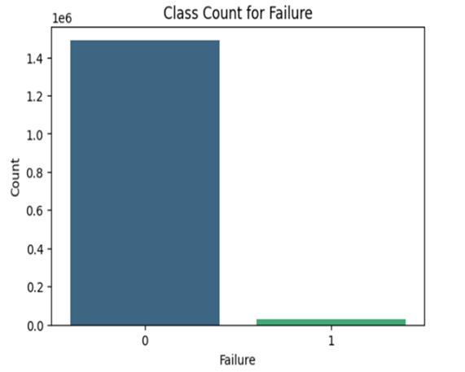
Figure 1.1.1. Imbalanced classes in Failure column of metro train dataset
Choosing ensemble methods over synthetic data generation approaches represents a crucial shift towards more reliable and interpretable predictive maintenance solutions. Ensemble methods harness the collective expertise of multiple base learners, each emphasizing different aspects of the data patterns present. This kind of approach is really helpful for metro train maintenance because missing actual failures (those false negatives) can be a big deal it can cause serious safety issues and mess up operations.
Also, we’re using advanced deep learning setups like CNN, LSTM, GRU, and TCN to build hybrid models such as the TCN-GRU. Basically, this combo lets TCN handle pulling out time-based features while GRU does a good job modeling sequences in time-series data. Putting them together helps make predictions more accurate, speeds up training, and reduces the chances of overfitting or underfitting.
Building these hybrid deep learning models is our way of getting around the limits of using just one type of architecture for tricky time-series prediction problems. TCNs are great at picking up long-term patterns using dilated convolutions while still being pretty efficient with computing, which is perfect for all the historical data you get from metro operations. Meanwhile, GRUs are solid for sequential modeling but use less computing power than classic LSTMs. By combining them in the TCN-GRU model, we’re trying to get the best of both worlds.
To deal with these huge time-series datasets without blowing up computing costs, we used a pretty straightforward statistical method called resampling perticularly, downsampling. It cuts down the size of the data but still keeps about 90% of the original variance, so our prediction accuracy doesn’t really take a hit.
Also, instead of using synthetic data from generative models like a lot of other studies do, we’re working with real data from the UCI repository. This data is actually labeled and comes straight from metro train components. We also clean it up with preprocessing steps like z-score normalization to make sure it’s high quality and reliable. Challenges in collecting real-world data in this domain will always exist, as it necessitates a multitude of sensors, machinery, time, and patience.
The utilization of real-world data offers a notable advantage in this research compared to studies that depend mainly on simulated or synthetic datasets. Actual operational data from metro systems captures the true complexity, noise, and variability that are inherent in real industrial environments. This realism is essential for creating predictive maintenance models that can function reliably in practical applications. The MetroPT-3 dataset [16], gathered from genuine metro train operations in Porto, Portugal, serves as a solid basis for developing and testing predictive maintenance algorithms.
The application of intelligent resampling techniques tackles the computational difficulties linked to managing large-scale time-series data without significantly losing the information content of the original dataset. By preserving 90% of the original data variance while considerably decreasing the dataset size, this method facilitates the creation of computationally efficient models that can be implemented in resource-limited operational settings typical of metro system control centers.
Basically, we’re using XAI methods to figure out and show which factors matter most for predicting failures. This works for both classifying failures and estimating Remaining Useful Life (RUL). The idea is to make things easier to understand so that maintenance crews can actually use the info to make better decisions and help prevent future problems.
Using Explainable AI is a big step forward for making predictive maintenance work in metro systems. Normally, machine learning models especially deep learning ones are kind of “black boxes.” They can be really accurate but don’t tell you why they made a certain prediction. That’s a big issue in safety-critical areas where maintenance teams need to actually understand the reasoning behind decisions.
By bringing in tools like SHAP (Shapley Additive Explanations) and LIME (Local Interpretable Model-agnostic Explanations), we’re trying to bridge that gap between having accurate models and being able to explain what’s going on.
The thing about making predictive maintenance explainable is that it’s not just about being see-through for the sake of it. When teams actually know which factors are behind failure predictions, they can go fix the real problems instead of just putting band-aids on. That’s especially important in metro systems, where there’s only so much time for maintenance, so you really have to make every minute count to keep services running smoothly.
In the end, by laying out our problem statement clearly, we’re aiming to tackle the gaps in existing research and build a more precise, understandable condition-based maintenance system just for metro trains. We’re using ensemble machine learning and hybrid deep learning methods on real historical time-series data to get better at both failure classification and estimating remaining useful life (RUL).
The proposed research framework tackles several crucial shortcomings in the existing practices of predictive maintenance for metro systems. By merging the strength of ensemble methods with the complexity of hybrid deep learning models, and ensuring interpretability through explainable AI (XAI) techniques, this study presents a thorough solution that strikes a balance between accuracy, efficiency, and real-world applicability. Emphasizing real-world data and specifically focusing on the Air Production Unit, an essential component for train safety, guarantees that the findings of this research hold direct significance for operational metro systems globally.
The primary research questions and contributions explored in this study include:
- In what ways can ensemble machine learning models (such as Random Forest, Gradient Boosting, and Bagging) be effectively employed to tackle class imbalance and other challenges in predicting metro train failures without depending on synthetic data generation?
- Which hybrid deep learning models (for instance, TCN-GRU) are most effective in enhancing prediction accuracy while reducing training duration and avoiding issues of overfitting or underfitting?
- What methods can be used to apply time-series data resampling techniques to extensive datasets in metro train failure prediction, in order to lower computational expenses while maintaining high variance and accuracy?
- How can XAI approaches be incorporated into failure prediction models to pinpoint and illustrate the most critical variables, thereby enhancing interpretability and assisting maintenance personnel in their decision-making processes?
This set of research inquiries addresses the core difficulties encountered when trying to implement efficient predictive maintenance systems within metro rail settings. The insights gained from these inquiries will enhance the overall field of industrial predictive maintenance while offering tailored solutions to meet the specific needs and limitations of urban transport systems.
The anticipated contributions of this research reach beyond the immediate context of metro train maintenance and have broader implications for predictive maintenance in intricate industrial systems. The techniques developed and verified in this study could be adapted for use in other transportation networks, manufacturing workflows, and infrastructure management scenarios that face similar issues related to large-scale time-series data analysis, class imbalance, and the necessity for understandable predictions.

Organization of report
Chapter 1 introduces the concept of predictive maintenance in metro train systems, emphasizing the necessity for accurate failure classification and Remaining Useful Life (RUL) estimation while addressing significant challenges. Chapter 2 examines the existing literature on machine learning, deep learning, and explainable AI methodologies relevant to predictive maintenance, highlighting the techniques used, identifying gaps, and suggesting future directions pertinent to metro systems. Chapter 3 outlines the scope and objectives of the study, specifically detailing the goal of developing an interpretable condition-based maintenance framework utilizing real-world data. Chapter 4 explains the methodology, which includes the collection and preprocessing of the MetroPT-3 dataset, feature engineering, the design and training of ensemble and hybrid deep learning models, as well as the implementation of explainable AI techniques. Chapter 5 showcases the results and discussion, comparing the performance of various models in failure classification and RUL prediction, and interpreting the outcomes using LIME and SHAP to identify key features and thresholds. Chapter 6 wraps up by summarizing the main findings, underscoring the advantages of the proposed methods for metro train maintenance, and Chapter 7 recommends avenues for future research and practical implementation.

Literature review

Basis of literature Review
The literature review commenced with a comprehensive examination of machine failures and predictive maintenance through the application of machine learning and deep learning algorithms across a variety of industrial machines, including metro trains, electric motors, semiconductor equipment, IoT systems, aircraft engines, rotating machines, elevator systems, hydraulic systems, induction motors, building cooling systems, hydroelectric power plants, truck air brake systems, software systems, and more. Aligned with the objectives and goals of our project, as well as the availability of suitable resources, including datasets, we chose 15 pivotal papers from a total of 33. These chosen papers concentrated on themes such as predictive maintenance, explainable AI (XAI) methodologies, metro train systems, and the estimation of remaining useful life (RUL).
For the studies we selected, we conducted a detailed review of the methodologies utilized, pinpointed existing research gaps, and evaluated the future research directions suggested by the authors. Based on this evaluation, we have constructed our framework designed to tackle the identified research gaps and enhance failure prediction techniques specifically for metro train systems.

Literature
N. Davari, B. Veloso, R. P. Ribeiro, P. M. Pereira, and J. Gama [1] emphasize the importance of identifying failures and errors before they happen and performing maintenance on air production units within the railway sector to avoid unexpected breakdowns and reduce downtime. The research introduces a methodology that incorporates data-driven failure prediction along with a maintenance framework that utilizes anomaly detection through deep learning techniques. It employs a sparse autoencoder network to identify unusual data from both analog and digital sensors within the air production unit system. Additionally, a low-pass filter is implemented to help detect failures. One of the constraints is the limited availability of labeled data for training purposes, the challenges of real-time execution, and the difficulties in managing large sets of multivariate time-series data. Future efforts will aim to increase the availability of labeled data, enhance the efficiency of real-time implementations, and develop precise methods for processing and visualizing significant amounts of multivariate time-series data.

O. N. NEAMAH and R. BAYIR [2] examine the prediction of faults in systems such as the MetroPT and metro PT-3 datasets within Industry 4.0 by utilizing machine learning algorithms to enhance system reliability and optimize the maintenance process, as well as to accurately detect faults before they arise. The study employs a framework of machine learning algorithms featuring advanced classification techniques, including reinforcement learning, K-nearest neighbors, and support vector machines, among others. These algorithms are leveraged for predictions, accompanied by confusion matrix reports and various metrics like accuracy and precision. One drawback of the research is the failure to investigate the scalability of the suggested framework, which demonstrates high accuracy within the dataset and its practical applications. To move past this limitation, future work could look into testing the framework on bigger datasets or by using more complex models in a variety of industries. It’d also be interesting to see how it handles real-time data streams and more advanced models—basically pushing the whole thing closer to real-world use.

Using ML and DL techniques that are user-friendly and cost-effective, A. Shinde, M. Motiramani, P. Soni, and A. Nanade [3] discuss forecasting the failure and managing its maintenance in the rail transportation sector to minimize the waste of valuable time and resources in the industry. The technique makes use of algorithms like LSTM, random forest, variational autoencoders, and boost. Additionally, this study emphasizes the use of time-based characteristics, such as lag and rolling statistics, to analyze time series data. The study has several limitations, including the trade-off between precision and recalls in the models, the fact that many businesses do not have a comprehensive system for forecasting when machines will fail, resulting in a waste of time and resources during unforeseen failures, and the effect of sample size and standard deviation on the results. Researchers may want to think about integrating risk and uncertainty into the process of train track maintenance and investigating the use of cutting-edge methods such as deep learning to develop a smart strategy, similar to the metaheuristic method, to address the study's shortcomings and apply it to actual train hubs in various places for practical testing.

A. P. Hermawan, D. -S. Kim, and J. -M. Lee [4] examines the prediction of the remaining useful life of aircraft engines, emphasizing the importance of delivering real-time information regarding engine conditions due to the engines' low tolerance for faults, which can result in significant accidents. Their approach utilizes a combination of CNN and LSTM models that learn from historical data patterns to accurately estimate the time until system failure. The CNN layer enables the model to identify features from past data, while the LSTM layer captures past information to forecast future outcomes. The study's limitations include the use of data from a single engine, which does not adequately represent real-world scenarios and the fact that earlier studies primarily compared modified algorithms without considering more complex datasets like those used in the current research. Future research could involve investigating additional real-world data and examining energy-efficient strategies that could be implemented moving forward.

J. Du, X. Gui, L. Song, S. Gao, C. Zhang, and X. Li [5] examine the prediction of failures and maintenance in mechanical equipment, aiming for more accurate estimations of remaining useful life to minimize downtime and costs associated with failures. The approach introduced in their study is the Transferable CNN-LSTM model, which combines CNN and LSTM networks to extract features from time-series sensor data. They use something called Domain-Adversarial Training of Neural Networks (DANN) to help their model adapt better to different equipment conditions. But the study points out some limits it wasn’t actually tested in real industrial settings, and it didn’t really deal with data quality issues or practical challenges of putting it into use. For future work, they wanted testing with real-world data, bringing in expert knowledge to improve the model, having better data-cleaning methods, and looking at adaptive approaches that can keep learning and adjusting as industrial conditions change to better predict equipment failures.

As for elevator systems, G. Verma, J. Awatramani, and N. Hasteer [6] talk about predicting failures and planning maintenance with a big emphasis on keeping things safe and reliable in modern buildings, while also trying to keep costs in check. Their study uses a random forest model to predict faults by pulling in sensor data, LSTM for handling sequences, and a deep autoencoder to extract important features. But it’s not without its downsides. There’s always the risk of unexpected events throwing off the model’s accuracy. Plus, they didn’t take things like holidays into account, even though those can totally change how often elevators get used and mess up maintenance planning. To improve the accuracy of maintenance scheduling, future studies will concentrate on resolving inconsistencies in the model and may include holiday data. Additionally, there will be an emphasis on creating flexible strategies for dealing with changing operational circumstances, which may increase the model's dependability.

The predictive modeling of data from industrial rotating machinery is covered by S. Gawde, S. Patil, S. Kumar, P. Kamat, K. Kotecha, and S. Alfarhood [7]. They emphasize the capacity to foresee potential machine failures and the difficulty of making AI/ML model decision-making processes understandable to people. They have included X-AI models in their research to resolve this problem. In addition to a combination of X-AI methods like LIME, and SHAP, paired with PDP and ICE for model interpretation, this study also includes multi-sensor data acquisition about various faults, statistical feature extraction in the frequency domain, and comparisons of results from different AI models. However, rather than concentrating on many faults, this work does not use a combination of different X-AI models to improve the clarity of choices or analyze machine data that only includes one kind of fault. Future directions that the study's limitations point to include researching the advantages of combining different X-AI strategies, focusing on the interpretation of predictions across various fault kinds, and developing more advanced, high-performance models together with their interpretations.

D. Pradeep, B. V. Vardhan, S. Raiak, I. Muniraj, K. Elumalai, and S. Chinnadurai [8] investigate the challenges faced by semiconductor manufacturing companies in optimizing their methods for identifying and forecasting manufacturing failures and maintenance, aiming to boost production while maintaining quality and controlling costs. The main focus of this study is the high rate of downtime in wafer fabrication equipment, much of which is related to unplanned maintenance. This situation results in reduced efficiency and increased expenses for both manufacturers and consumers. The researchers applied various machine learning and neural network algorithms to predict manufacturing failures and maintenance needs. They made use of the secom dataset from the UCI repository, which contains 1,567 records related to semiconductor manufacturing, and conducted processes such as data cleaning, attribute selection, model building, and model assessment. There is a thing this study did not focus on such as fancy algorithms to cut down on surprise maintenance in semiconductor factories but also ignores the main reasons behind resource shortages and health problems that can delay the production. It also doesn’t really get into the real-world headaches of actually using these maintenance methods on the factory floor. For future work, it'd be smart to look at what really causes those shortages and health issues in the first place, and figure out how to actually get these machine learning approaches working smoothly in real production so they’re more accurate and reliable.

M. N. Al-Andoli and colleagues [9] came up with a hybrid ensemble model that mixes machine learning (ML) and deep learning (DL) to improve fault prediction in industrial machines. Their setup uses two base models and a meta-model, all running in parallel, which helps speed things up. The base models combine hybrid backpropagation with particle swarm optimization to fine-tune features and parameters. When they tested it on a standard dataset, it delivered better accuracy and faster processing times than older, more manual methods. But there’s a downside: deep learning’s heavy use of gradient descent can eat up a lot of computing power and doesn’t always find the best answer. Down the line, it’d be smart to look into faster, more efficient optimization tricks or try out other AI approaches to push accuracy even further.

To improve system availability, decrease downtime, and save maintenance costs, T. Son Pham, D. Huy Nguyen, and N. Duy Minh Phan [10] have classified ball-bearing system failures and maintenance concerns. Using interpretable machine learning techniques, this work determines the parameters that influence the model's performance and attains high failure classification accuracy. They implemented ensemble methods such as Random Forest, Gradient Boosting, and AdaBoost for their predictions and integrated interpretable algorithms like SHAP to clarify the most important features for each failure type through both local and global analyses of the system's dataset. A potential drawback of the study is its dependence on Random Forest techniques, which require substantial computational resources due to the use of multiple trees, making interpretation with the previously mentioned model challenging. Furthermore, the research necessitates a more adaptable algorithm that can respond to operational changes in the system over time. Considering these limitations, a future direction for the paper could involve developing a flexible algorithm capable of adjusting to the system's operational changes and enhancing the interpretable algorithms used in the model for classifying failures with high-dimensional data.

K. T. Selvi, N. Praveena, K. Pratheksha, S. Ragunanthan, and R. Thamilselvan [11] examine the challenges of anticipating and maintaining air pressure system failures, specifically in Scania truck air brake systems. Each class may not be fairly represented in the real-world data that is gathered, which could lead to inaccurate failure detection or system classification. Techniques like SMOTE, under-sampling, and over-sampling were employed to address this issue and achieve class balance. To obtain forecast accuracy for system failures, the study employs classification methods such as SVM, Random Forest, Naïve Bayes, and Logistic Regression. One limitation is that the study could use attribute selection techniques to identify the most crucial attributes for prediction and address problems with managing unbalanced real-world data prior to making predictions in order to improve model performance. Future initiatives for the study can include using more sophisticated attribute selection techniques to identify the most crucial elements in brake system failures.

In order to solve the issue of unbalanced data in software datasets, E. Elahi, S. Kanwal, and A. N. Asif [12] employed the ensemble approach to enhance the prediction of software failures. This can lead to better software quality and cheaper maintenance costs. This study enhances the prediction model's performance by carefully selecting the optimal combination of classifiers and resampling techniques within the model averaging method. Model averaging, stacking, and voting are examples of ensemble techniques used in the study to enhance the prediction model's performance. To produce the ultimate predictions, it uses some resampling techniques, such as SMOTE and ROS, with some classifiers, such as logistic regression, KNN, and decision trees. Statistical tests, such as the Friedman test and ANOM test, are used to find the importance of the results and find the best combination of classifiers and resampling techniques. The study's drawback is the absence of genuine software datasets from the actual world for wider application, as the tests are carried out using data from the PROMISE repository. Furthermore, some of the selected classifiers may limit the experiment's ability to investigate alternative combinations that could improve the accuracy of its predictions. Future directions for research may involve using real-world software datasets for broader insights, creating a more effective ensemble method that combines classifiers and resampling techniques for failure prediction, and exploring the prediction of various fault types through different ensemble methods.

S. Bundasak and P. Wittayasirikul [13] explore the advancement of predicting motor failures, assessing their condition, and planning their maintenance with the help of AI. This research forecasts the potential damage and longevity of motors that transform electrical energy into mechanical energy in production processes. It identifies motor malfunctions early, before failure, and alerts maintenance personnel through a website, thereby minimizing motor downtime and enhancing maintenance effectiveness. The research also includes a method for analyzing the data and electrical parameters gathered from the operating motor. Furthermore, the study implements a website system using Python, PHP, and JavaScript, employing a logistic regression model, and assesses the performance of various algorithms such as K-NN, Logistic Regression, Naïve Bayes, and SVM for predicting motor health. One constraint noted in the study is the challenge of gathering additional test data, as the data collection process for training can be quite lengthy. The research highlights that if the test data falls outside the training set, predictions may not be accurate, and the system may struggle with large or noisy datasets. Future plans include gathering more datasets and training data through APIs to save time. The study also indicates that obtaining test data should not be overly demanding in terms of effort or resources, as simpler data collection would facilitate more effective testing.

R. B. Mofidul, S. S. Alam, A. Chakma, B. Chung, and Y. M. Jang [14] discuss a method for forecasting failures and maintenance in solar energy systems by implementing group algorithms to estimate maintenance timelines using a limited number of features present in the systems. Their study utilizes a dataset from a 99.9 kW solar panel system, focusing on factors such as DC voltage, DC, instantaneous power output, power factor, and frequency. The main goal of this research is to develop a system that determines the most effective group algorithm through performance assessments and identifies crucial features like DC voltage and DC for model predictions. The methodology employed in this research includes constructing a data frame from the solar system data, selecting significant features, and splitting the dataset into training and testing samples at a 4:1 ratio. Various group models, including RandomForest, XGBoost, CatBoost, and LightGBM, are trained and subsequently tested on the data for predictions, with XGBoost yielding the highest results, achieving an accuracy of 98.62% and a precision of 94.37%. In conclusion, performance metrics like accuracy and precision are utilized to assess the results of each model. The study identifies a gap in the literature regarding the use of ensemble techniques with a minimal set of features for forecasting maintenance in these systems. Taking into account the limitations, future directions may involve research and improvements in ensemble techniques for predictive modeling of solar energy systems, as well as exploring the use of additional features and different algorithms within the research framework for enhanced predictions and maintenance strategies.

T. Khan, K. Ahmad, J. Khan, I. Khan, and N. Ahmad [15] discuss the challenges associated with forecasting equipment failures in industrial environments, particularly focusing on estimating the Remaining Useful Life (RUL) of machinery. As industries heavily depend on sophisticated machines, monitoring and ensuring optimal machine performance over time becomes an essential responsibility. Traditional machine learning methods frequently act as "black boxes," which can erode stakeholders' trust in their forecasts even though they can yield useful performance metrics like Mean Squared Error (MSE). The authors suggest a more transparent regression framework that incorporates X-AI techniques, particularly LIME and SHAP, to solve this problem. By providing insight into the prediction process, this framework aims to increase comprehension and confidence. It has two main parts: feature selection and machine learning-based prediction creation, followed by X-AI models that explain these predictions. While SHAP gives both local and global interpretations, offering a comprehensive picture of the model's operations, LIME delivers localized insights by assessing how changes in input examples impact model predictions. The article also points out several drawbacks, namely the compromise between machine learning models' interpretability and accuracy. Achieving both great performance and clear explanations may be hampered by the complexity of some models. Furthermore, the study ignores other X-AI techniques in favor of LIME and SHAP, and the results might be constrained by the particular datasets that were employed. By investigating alternative XAI approaches such as Grad-CAM or DiCE, creating algorithms that balance accuracy and transparency, testing the framework in various industrial settings, and customizing explanations to satisfy the various demands of various stakeholders, future research could overcome these limitations and improve decision-making processes.

Summary of literature
Utilizing machine learning (ML), deep learning (DL), and explainable artificial intelligence (XAI) techniques, the studied literature presents a wide range of predictive maintenance and failure prediction strategies used in different industrial sectors. In order to detect faults and improve dependability, studies [1], [2], and [3] focused on predictive maintenance in the railway sector, namely metro train systems. They used techniques including autoencoders, LSTM, and conventional ML algorithms. These research efforts point out challenges including imbalanced datasets, insufficient labeled data, and difficulties with real-time implementation.
Studies [4] and [5] expanded the application of CNN-LSTM and transferable DL architectures in predicting remaining useful life (RUL) for aircraft engines and mechanical systems, highlighting the necessity for strong temporal feature extraction and domain adaptation. Maintenance of elevator systems was examined in [6], which applied sensor-driven DL techniques but faced challenges in accommodating dynamic usage patterns like holiday schedules and unexpected fluctuations in demand.
Research on industrial rotating machinery and semiconductor manufacturing was conducted in [7] and [8], where ensemble models and XAI tools such as SHAP and LIME were utilized to enhance interpretability and fault detection. Paper [9] presented a parallel hybrid ensemble model aimed at increasing prediction efficiency in industrial contexts, while [10] implemented interpretable ML in ball-bearing systems using SHAP to assess feature importance, citing computational overhead as a limiting factor.
The examination of Scania truck air brake systems and software failure predictions occurred in [11] and [12], respectively, both addressing data imbalance with the use of SMOTE and ensemble techniques such as random forest, logistic regression, and voting classifiers. The focus of [13] was motor health monitoring through AI with online deployment strategies, emphasizing issues related to real-time alerts and system scalability.
In the energy sector, [14] explored predictive maintenance in photovoltaic systems through group ensemble models (XGBoost, LightGBM, etc.) based on a minimal set of features, achieving high accuracy but lacking broad applicability. Lastly, [15] introduced a regression-based RUL prediction framework that integrated SHAP and LIME to bolster model transparency, highlighting the need for interpretability in essential industrial applications.
Together, these studies emphasize a number of common challenges. The future research avenues proposed across these papers include the integration of hybrid ML-DL models with XAI tools, enhancing data preprocessing and feature selection techniques, and creating scalable, generalizable frameworks for industrial predictive maintenance.

Research Gap
- Handling Imbalanced classes in Datasets
- Issue: Failure events are rare compared to normal operations, leading to class imbalance.
- Impact: Models often become biased toward normal conditions, missing critical failures and reducing prediction reliability, especially in safety-critical systems like metro trains.
- Overfitting and reliance on synthetic data
- Issue: Techniques like SMOTE, oversampling, etc. introduce artificial patterns to balance data.
- Impact: Models trained on synthetic data may overfit and perform poorly in real-world scenarios, jeopardizing safety and trust in predictions.
- Handling massive multivariate time-series data
- Issue: Sensor-rich environments generate large, complex datasets with high dimensionality.
- Impact: Conventional ML models struggle to capture temporal dependencies, leading to reduced accuracy and missed failure patterns.
- High computational costs
- Issue: Training and running models on large-scale time-series data requires substantial processing power.
- Impact: Increases operational cost and hampers real-time deployment, which is essential for timely maintenance.
- Limited labeled data
- Issue: Real failure labels are scarce due to infrequent breakdowns and the cost of manual annotation.
- Impact: Limits supervised learning and hinders model training, reducing prediction accuracy and generalizability.

Scope of the work and objective

AIM
To create a reliable and interpretable condition-based maintenance system for metro trains by utilizing ensemble machine learning and hybrid deep learning approaches, enhancing failure classification and estimating remaining useful life (RUL) based on actual time-series sensor data.

SCOPE
Included:
- Emphasis on maintenance based on conditions, utilizing historical sensor information from metro trains.
- The application is restricted to the Air Production Unit (APU), which is a vital subsystem responsible for braking and door functions.
- Employing the real-world dataset (MetroPT-3) for classifying failures and predicting Remaining Useful Life (RUL).
- Utilizing ensemble machine learning models and hybrid deep learning architectures (TCN-GRU).
- Incorporating Explainable AI (XAI) into ensemble models to enhance understandability.
Excluded:
- Real-time streaming of sensor data and implementation.
- Challenges with providing interpretability for deep learning models when it comes to time-series explanations.
- Extension to other metro components or various industrial systems.

OBJECTIVES
The objectives are to work on following points.
- To tackle class imbalance in metro train failure data without resorting to synthetic data by implementing ensemble methods such as Random Forest, Bagging, XGBoost, and Stacking.
- To boost the precision of RUL prediction by constructing a hybrid deep learning architecture (TCN-GRU) that merges temporal feature extraction with sequential modeling.
- To decrease computational demands and training duration through the application of downsampling techniques while preserving over 90% of the dataset’s variance.
- To improve model interpretability via Explainable AI (XAI) methods (LIME and SHAP) applied to ensemble models to pinpoint critical features related to failures.
- To test the proposed models using the real-world MetroPT-3 dataset, concentrating on the Air Production Unit to ensure practical significance and optimal performance.

Methodology
The research focuses on categorizing failures and estimating the remaining useful life by utilizing ensemble machine learning models and hybrid deep learning models for the MetroPT-3 Dataset [16]. The approach or procedures employed for this implementation are illustrated in Figure 4.1 below.
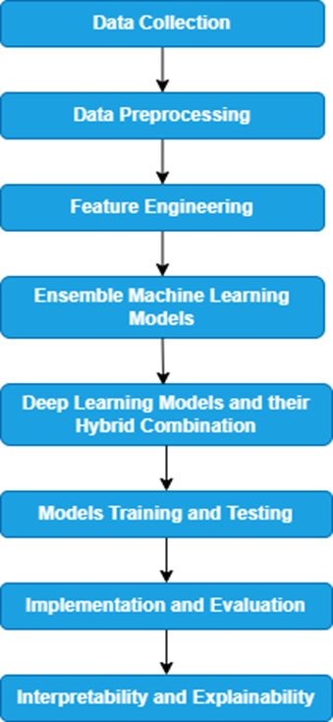
Figure 4.1. Methodology
Figure 4.1 displays a flowchart that summarizes a typical machine learning pipeline, while Figure 4.2 presents a specific practical example through a block diagram. Importantly, this block diagram includes an extra feedback loop, where insights from human observation and maintenance activities contribute to enhancements of the model. This connection directly relates to the "Implementation and Evaluation" as well as the "Interpretability and Explainability" phases of the general pipeline, but within a practical and iterative context focused on machine health.
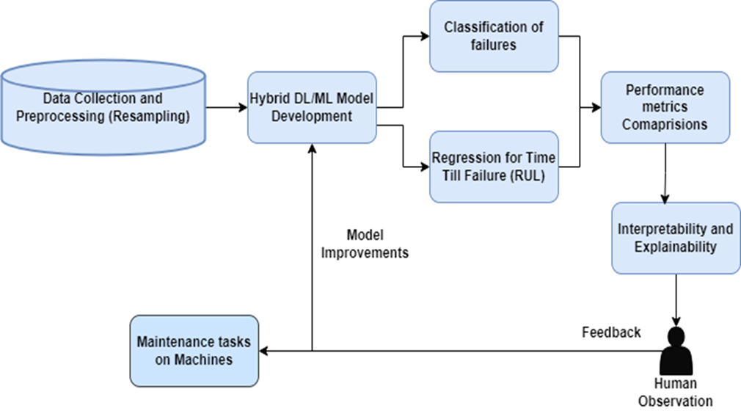
Figure 4.2. Block Diagram
4.1 Data Collection
The MetroPT-3 dataset [16], available from the UCI repository, stems from a research study [1] conducted in Porto, Portugal, which focuses on the Air Production Unit (APU) of metro trains. This dataset contains 1.5 million multivariate time-series data points collected between February and September 2020, with a sampling frequency of 0.1 Hz, signifying that each measurement was captured every 10 seconds. It features a timestamp column along with measurements from 7 analog sensors and 8 digital sensors that track 15 essential signals. The 7 analog sensors capture continuous variables such as pressure at various locations (compressor, pneumatic panel, filters, reservoirs), motor current, and oil temperature, while the 8 digital sensors deliver binary on/off signals for occurrences like compressor operation, air discharge, drying tower functionality, pressure drops, and oil levels as described below:
For analog sensors, we have pressure, temperature, and electrical current consumed at different sections of the APU, as outlined below:
- TP2 (Pressure) (bar): Monitors the pressure within the compressor.
- TP3 (Pressure) (bar): Records the pressure at the pneumatic panel, crucial for the train's functionality.
- H1 (Pressure) (bar): Measures the drop in pressure when air is released from a filter.
- DV Pressure (bar): Assesses the pressure drop when air dryers expel air; a zero reading signifies that the compressor is under strain.
- Reservoirs (Pressure) (bar): Gauges the pressure within the air storage tanks, which should be comparable to the pressure at the pneumatic panel (TP3).
- Motor Current (A): Indicates the electrical current utilized by the motor.
- Oil Temperature (°C): Monitors the temperature of the oil within the compressor.
Regarding digital sensors, those fitted in the APU can only produce two possible values: zero for inactive status or one for an activated event. The relevant digital sensors are as follows:
- COMP (Air Intake Signal): Shows whether the compressor has ceased air intake. It is active when no air is being drawn.
- DV Electric (Outlet Signal): Indicates if the compressor is expelling air. It is active when the compressor operates at full capacity.
- TOWERS (Drying Signal): Identifies which tower is responsible for drying the air. Tower one is operational if inactive, while tower two is working if active.
- MPG (Start Signal): Engages the compressor when the pressure falls below 8.2 bar, ensuring it activates when necessary.
- LPS (Low Pressure Signal): Triggers when the pressure dips below 7 bars, signaling a potential issue.
- Pressure Switch: Detects when air is being released from the drying towers.
- Oil Level: Indicates whether the oil level in the compressor is inadequate.
- Caudal Impulse (Air Flow): Measures the airflow from the air compressor to the air tanks (reservoirs) for various operations. Insufficient flow may suggest an issue with the compressor or the air supply system.
For essential train functions such as braking and door operation, the APU consists of the following components:
1. Air Intake Valve: This part manages how much surrounding air is drawn into the system. It serves as a controller, opening to permit air entry when compression is necessary and closing when it is not required. Electrical signals from digital sensors oversee its functionality.
2. Air Filter: The air filter purifies incoming air by eliminating dust and particulates, safeguarding downstream elements like the compressor from contamination. It is an integral aspect of the standard air handling procedure.
3. Air Compressor: This is the central component that compresses the filtered air to produce the high-pressure air needed for hydraulic or pneumatic tasks. The compressor's current is tracked through analog sensors (Motor Current), supplying information about its operational condition.
4. Air Tanks (Reservoirs): These containers hold the compressed air created by the compressor, functioning as buffers to provide a consistent air flow for the train’s operational requirements, such as braking and door movement.
5. Air Drying System: This mechanism extracts moisture from the compressed air to avoid corrosion and guarantee operational consistency. It includes towers that dry the air and then drain the moisture-removed air, with digital sensors indicating the progress of these operations.
Operational Workflow of APU components:
- Ambient air enters through the Air Intake Valve and moves on to the Air Filter, where it is purified.
- The refined air is then routed into the Air Compressor, which compresses it to the necessary pressure.
- The compressed air is then sent to the Air Tanks, where it is stored at high pressure.
- A portion of the stored air is taken by the Air Drying System to expel moisture, ensuring top-quality compressed air for dependable operation.
- The treated, high-pressure air is delivered through controlled valves and pipelines to the operational systems for braking and door management.
To label the “Failure” column for failure classification and the “Hours till Failure” column for remaining useful life (RUL) prediction in the dataset above, we utilized the failure report provided in the same paper [1] along with data from the MetroPT-3 dataset available on the UCI repository website. The methodology employed by the authors in paper [1] to generate this failure report is thoroughly outlined in that paper. Figure 4.1.1 below illustrates the failure report from paper [1] in detail:
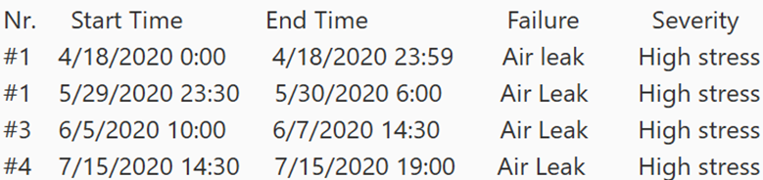
Figure 4.1.1. Failure Report available in Paper [1].
Initially, the 'timestamp' column within the dataset and the start and end timestamps from the failure report were converted to a datetime format. The "Failure" column in the dataframe is labeled by comparing each timestamp to the predefined failure periods specified in the failure report dataframe. If a timestamp occurs within a specific failure period outlined in the report, the corresponding failure type "AirLeak" is assigned based on the report, while any other timestamps default to "NoAirLeak." The same approach can be applied to label the “Severity” column with categories of high, low, and medium stress.
The "Hours_till_Failure" column is generated by calculating the time difference between each timestamp in the dataset and the start time of the closest upcoming failure period from the failure report, as long as the timestamp occurs before the start of the failure period. This time difference is then transformed into hours. If the timestamp is within an ongoing failure period, the value is recorded as 0. For timestamps that take place after all failure periods, the value also defaults to 0, since those failures are regarded as logged. This logic is encapsulated in a function that was applied to the timestamps in the df dataset, resulting in the creation of the "Hours_till_Failure" column.
The dataset obtained after labeling will resemble the following Figure 4.1.2:
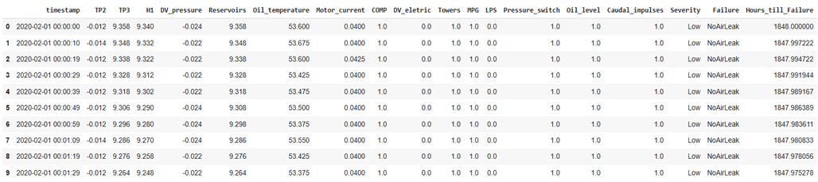
Figure 4.1.2. MetroPT-3 dataset [16] after labelling
4.2 Data Preprocessing
The original dataset contained no missing values. The preprocessing procedures were carried out as follows:
1. Data Encoding: After labeling the dataset, we utilized the map() function for manual mapping to encode data in the "Failure" column, assigning a value of 1 to "AirLeak" and a value of 0 to "NoAirLeak" to support precise classification of failures across various models. A similar technique was applied to the "Severity" column, where "Low" was mapped to 0, "Medium" to 1, and "High" to 2.
2. Time series dataset resampling (down-sampling): Following the encoding of the dataset, we addressed problems such as reformatting improper timestamp data into a correct sequence and reducing the dataset's size, which initially comprised approximately 1.5 million records. Since there were many similar sensor readings in each column, we executed 2-minute (2T) downsampling using the resample() function. This action decreased the dataset from 1,516,948 records to 126,527 records. During this process, we aggregated numerical analog sensor columns by computing their mean values, while for digital sensor columns, we applied the mode value because of their binary nature (0 and 1). After resampling, some records contained NaN (missing) values, which were later removed. This occurrence of missing values was due to incorrectly formatted timestamp data being converted into the correct format during the resampling, resulting in absent records in the dataset.
Subsequently, a statistical measure known as variance percentage was computed for each column, as represented by equation (1):
$Variance Percentage \left(\%\right)= \frac{variance of each columns after resampling }{Original varience of each column}× 100$ (1)
The percentage of variance for each column after resampling, in comparison to the initial dataset, varies from approximately 3.9% (for Pressure_switch) to 103.1% (for MPG), with the majority of columns maintaining over 90% of their variance. This suggests that the resampling process had a minimal impact on the dataset's variability, indicating that the resampled dataset is likely still appropriate for analysis and predictive tasks.
3. Normalization using Z-score (standard scaler): The data points in each column were converted to their respective Z-score values utilizing the Z-score formula. This transformation results in a mean equal to 0 and a standard deviation equal to 1 for each column. Although certain classical models necessitate scaling prior to making predictions to ensure the data is centered around 0 and exhibits a uniform scale, this is not essential for failure classification tasks. This is due to our use of both ensemble and hybrid methods, which are capable of managing data with varying scales. Nevertheless, Z-score normalization was specifically employed for predicting "Hours_till_Failure" because of the value range in this feature, which goes from 0 to 1847.98. Without scaling, this broad range could result in substantial errors in the final predictions of remaining useful life. Once scaling is complete and predictions are made, we can utilize the inverse transform function available in Python's standard scaler to view the original predicted “Hours_till_Failure” values. The formulas for scaling and inverse scaling can be expressed as follows in equation (2):
$$z=\frac{(x-m)}{std} (2)$$
with z being the Normalized feature values, x standing for the original columns values, m standing for the mean of the each columns, and std standing for the standard deviation for each columns.
4.3 Feature Engineering
Once data preprocessing was complete, a correlation heatmap was utilized to examine the relationships between each column and the target column in the pre-processed dataset, as illustrated in Figure 4.3.1.
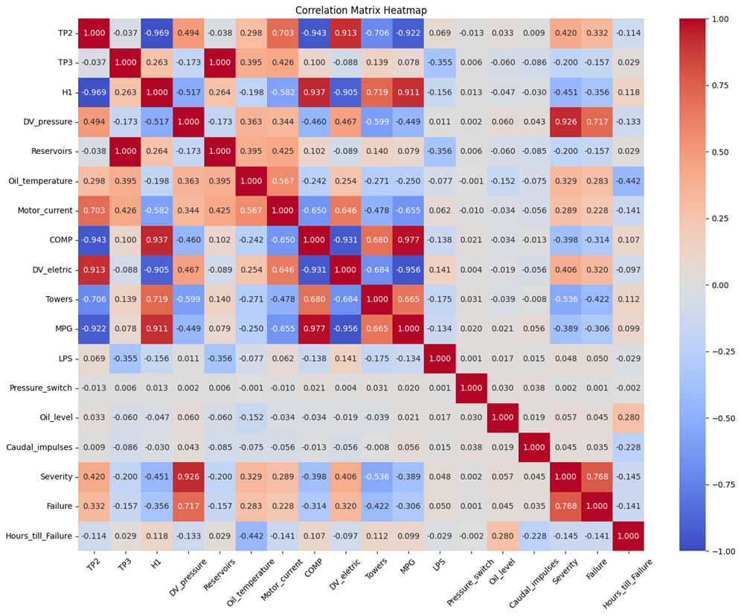
Figure 4.3.1. Correlation Heatmap
When evaluating the correlation with "Failure" (binary classification target), Severity (0.768) demonstrates the strongest positive correlation, highlighting its importance as a predictor of imminent failure. Caudal_impulses (0.700) and Oil_level (0.619) also exhibit strong to moderate positive correlations, indicating that increases in these features are linked to a higher likelihood of failure. Pressure_switch (0.370) provides moderate relevance, while other variables like LPS (0.048) and MPG (0.009) show minimal impact. Negative correlations are observed with Oil_temperature (-0.254) and DV_eletric (-0.194), suggesting that lower values in oil temperature and electric readings could be associated with failures. As expected, Hours_till_Failure (-0.141) has an inverse relationship, reinforcing the idea that less time remaining correlates with a higher probability of failure.
The pre-processed dataset intended for classifying "Failure" will logically omit the timestamp column, as it serves merely as an identifier and lacks predictive value. Moreover, the Severity and Hours_till_Failure columns will be removed. Since Hours_till_Failure is closely linked to the failure event, including it as a feature would lead to data leakage when predicting Failure. Similarly, Severity, having a very high correlation with Failure, would result in data leakage if retained, inflating model performance in a way that would not generalize to new data. The remaining features, representing various sensor readings and operational parameters, will serve as independent variables for the classification models.
For predicting "Hours_till_Failure" (regression target), most features reveal weak correlations. The positively correlated variables include Towers (0.422), COMP (0.314), MPG (0.306), Motor_current (0.289), and Oil_temperature (0.283)—indicating that elevated values in these features generally correlate with a longer operational lifespan. Conversely, Severity (-0.141) and Caudal_impulses (-0.028) display weak negative correlations, suggesting that increases in these parameters might lead to a slight reduction in the remaining hours until failure. Overall, while the classification target presents clearer predictive features, the regression target relies on more intricate and spread-out relationships.
When predicting "Hours_till_Failure," the timestamp column will be removed from the pre-processed dataset. The Failure column will also be excluded because it represents the outcome we are trying to predict in terms of remaining time. Including Failure as a feature for forecasting Hours_till_Failure would introduce data leakage. The Severity column will be kept in this context as a possible predictor for Hours_till_Failure despite its association with Failure because it represents the system's current state, which is pertinent to the amount of time left. Since they offer crucial information on the system's operational state, which affects the time to failure, the remaining columns will all be used as features for the regression models.
In conclusion, columns like timestamp, severity, and hours_till_failure were eliminated from the pre-processed dataset used to categorize the target column "Failure," while the remaining attributes were used for classification. Likewise, the timestamp column was removed from the pre-processed dataset used to predict "Hours_till_Failure," while the other columns were subjected to several prediction models. Finally, to determine the most important characteristics influencing the final failure classification and remaining useful life predictions, we will also utilize XAI techniques like LIME and SHAP.
4.4 Ensemble Machine Learning Models
We employed a set of ensemble machine learning models to reliably classify failures and estimate the remaining usable life (RUL), expressed as Hours_till_Failure. To improve strength, reduce variance, avoid overfitting, and increase forecast accuracy, ensemble approaches combine many base models. The four ensemble approaches used in this study provide distinct benefits designed for particular modeling problems, and they are as follows:
1. The Random Forest: This model uses randomly chosen features and data to construct several decision trees. To improve accuracy and reduce overfitting, the output from these trees is aggregated either by voting (for classification) or by averaging (for regression).
2. XGBoost, or Extreme Gradient Boosting: combines weak learners (often decision trees) in a sequential manner. Every new model uses gradient descent to optimize a loss function in an effort to reduce the errors of the previous one. Regularization techniques (L1|L2) are used to prevent overfitting, which makes it especially useful for complex datasets.
3. Bagging: Bagging involves training multiple models on randomly selected dataset subsets and aggregating their predictions by average (for regression) or voting (for classification). While Bagging's structure is similar to Random Forest's, it can use any conventional model as a base estimator. Decision trees were chosen as the foundational method in this study.
4. Stacking: Stacking merges predictions from various base models by utilizing a meta-model that learns from their outputs. This technique improves accuracy by capitalizing on the strengths of individual models. In our analysis, Random Forest and XGBoost were chosen as base models, with XGBoost acting as the meta-model.
4.5 Deep Learning Models and their Hybrid Combination
To classify failures and estimate the remaining useful life (Hours_till_Failure), we employed four deep learning approaches: CNN, LSTM, GRU, and TCN. The models that performed the best were merged (TCN-GRU) to develop a hybrid model that demonstrated improved accuracy and decreased training duration. The time-series models (LSTM, GRU, and TCN) divided the dataset into fixed-length sequences (timesteps=10) for analysis. Each model utilized two dense layers: the first comprised 64 neurons with ReLU activation, and the second contained a single neuron (sigmoid for classification purposes and none for regression). A dropout rate of 0.2 was implemented in the dense layers (as well as between layers in RNN-based models) to reduce the risk of overfitting. The models were fine-tuned for time-series data with suitable activation functions (ReLU and sigmoid), and pooling layers were omitted in both CNN and TCN to preserve crucial information.
1. CNN (Convolutional Neural Network): CNNs, traditionally utilized for image processing, were modified to address time-series challenges and to extract spatial patterns. The architecture included two layers convolutional having 64 filters, a kernel or filter matrix having size of 2, activation function as relu, and maintained the same padding, without incorporating pooling layers. The output was converted to a 1D format prior to proceeding to the dense layers.
2. LSTM: L-Long, S- Short, T- Term, M- Memory, a variant of R-NN algorithm, were employed to capture long range dependencies within time series data. The method made use of cell states and different types of gates, including input, forget, and output. The architecture featured two layers of LSTM, each layer containing 64 neurons with activation function as relu, having drop out applied in between layers before connecting to the dense layers.
3. GRU (Gated Recurrent Unit): GRUs, a simplified version of RNN, effectively captured long-term dependencies using gating techniques. The architecture comprised two GRU layers with 64 neurons and ReLU activation, with dropout incorporated between layers before the output was sent to the dense layers.
4. TCN (Temporal Convolutional Network): TCNs utilized dilated convolutions to grasp long-range dependencies, making them well-suited for time-series forecasting. The model consisted of two layers convolutional having 64 filters, a kernel or filter matrix having size of 2, activation function as relu, and utilized causal padding. The dilation rates for the two layers were set at 1 and 2, respectively. The outputs were reshaped into a 1D structure before being directed to the dense layers.
5. Hybrid Model (TCN-GRU): The TCN-GRU hybrid combined the advantages of TCNs for extracting extensive temporal features and GRUs for recognizing sequential patterns. Outputs from the two TCN convolutional layers were directed into two GRU layers, followed by flattening and then the dense layers. The same parameters and configurations as the individual TCN and GRU models were applied. Our proposed hybrid model in practical application would be represented in the architecture illustrated in Figure 4.5.1.
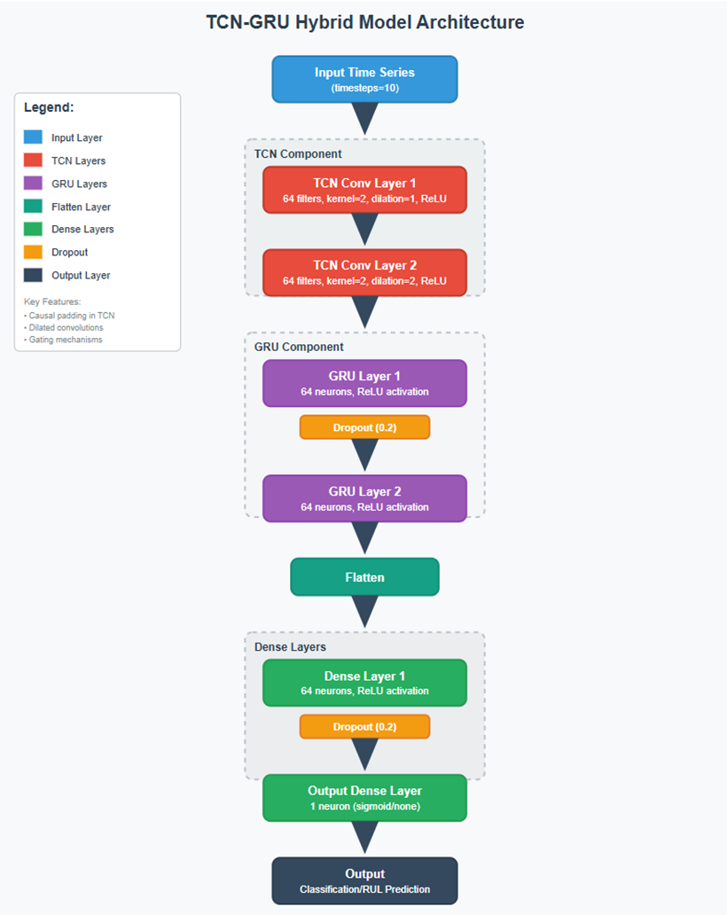
Figure 4.5.1. Hybrid model (TCN-GRU) Architecture
4.6 Models Training and Testing
The pre-processed and downsampled dataset was divided into training and testing sets, comprising 80% and 20%, respectively, while ensuring both subsets maintained a balanced representation of failure and non-failure instances for an unbiased model evaluation.
Instead of using automated tuning algorithms, hyperparameters for all models were manually fine-tuned. This process involved modulating parameters based on performance metrics observed during testing. In the case of ensemble models, parameters like n_estimators (the number of trees), max_depth (the depth of individual trees), and learning_rate (for XGBoost) were adjusted manually to find a balance between model complexity and predictive performance, minimizing the risk of overfitting.
For deep learning and hybrid models, the Adam optimizer was chosen for its adaptive learning rate and computational efficiency, making it especially suitable for time-dependent data. A learning rate of 0.001 was set during the model compilation to enable adequate learning without surpassing local minima. The choice of loss functions depended on the task at hand: binary cross entropy for classification tasks and mean squared error (MSE) for predicting Remaining Useful Life (regression).
For time-based models, input sequences were divided using a fixed timestep of 10, which ensured that the models could recognize meaningful patterns while avoiding memory overflow during training. A batch size= 64 and an epoch count= 50 were utilized, with dropout rates manually adjusted (set to 0.2) between dense and recurrent layers to mitigate overfitting. Early stopping techniques and monitoring of validation loss were employed during training to halt unnecessary epochs once convergence of the model was achieved.
The hybrid TCN-GRU model was compiled using the same optimizer and learning rate. Its training procedure mirrored that of other deep learning models, with no pooling layers applied to retain all temporal information.
All models were trained and assessed with the same train-test split to guarantee a reliable comparison across ensemble, deep learning, and hybrid methodologies. Cross-validation was not utilized due to the extensive size of the time dependent dataset and the significant computational demands of repeatedly training deep and hybrid models. Furthermore, given that the data reflects sequential time-dependent behavior, maintaining temporal order was crucial, rendering traditional cross-validation methods less appropriate. Throughout the training process, model checkpoints, training histories, and loss curves were monitored to confirm model stability and convergence.
4.7 Implementation and Evaluation
To determine the most effective models among ensemble machine learning, deep learning, and hybrid approaches, this research utilized a range of well-recognized evaluation metrics. These metrics were selected based on the nature of the task: classification (failure prediction) or regression (Remaining Useful Life, RUL estimation).
1. Classification Metrics: In the binary classification of metro train failures (i.e., AirLeak vs. NoAirLeak), the following metrics were employed, with a primary emphasis on F1-score (the balanced value of precision and recall), Recall (as missing a failure poses safety risks), and precision (crucial for minimizing false alarms), to assess different models:
Accuracy: Equation (3) represents the section of instances that were correctly classified:
$$Accuracy=\frac{(TN+TP)}{(TN+TP+FN+FP)} (3)$$
With,
True Positive (TP): The model accurately predicts a failure (AirLeak) when a failure indeed occurs.
True Negative (TN): The model accurately predicts no failure (NoAirLeak) when there truly isn't a failure.
False Positive (FP): The model forecasts a failure (AirLeak) when, in fact, there is no failure (NoAirLeak) - this is a false alarm.
False Negative (FN): The model expects no failure (NoAirLeak) while a failure (AirLeak) actually exists - a serious oversight in safety situations.

Precision: Equation (4) represents the accuracy of positive predictions:
$$Precision=\frac{TP}{(FP+TP)} (4)$$
Recall: Equation (5) measures the model’s capability to identify all relevant instances:
$$Recall=\frac{TP}{(FN+TP)} (5)$$
F1-Score: Equation (6) check the balanced value of precision and recall:
$$F1 score=\frac{(recall×precision×2)}{(recall+precision)} (6)$$
These metrics are particularly effective for imbalanced datasets, where relying solely on accuracy can be misleading.
2. Regression Metrics: In the context of RUL prediction, several regression metrics were utilized to measure the discrepancy between actual and predicted values, with particular emphasis on r2 and RMSE for model comparison:
Mean Squared Error (MSE): Equation (7) calculates the average of the squared errors:
$$MSE=\frac{1}{N}\sum_{i=1}^{N}{{(y_{i}-{y_{i}}^{'})}^{2}} (7)$$
Having:
The actual testing values are represented as $y_{i}$,
The predicted testing values are denoted as ${y_{i}}^{'}$,
And N symbolizes the number of samples in the testing dataset.
Root Mean Squared Error (RMSE): Equation (8) is derived from MSE and helps interpret the error in the same units as the output variable:
$$RMSE=\sqrt{MSE} (8)$$
Mean Absolute Error (MAE): Equation (9) assesses the average size of the errors in a group of predictions:
$$MSE=\frac{1}{N}\sum_{i=1}^{N}{|y_{i}-{y_{i}}^{'}|} (9)$$
R2 Score: Equation (10) indicates how much of the variance in the dependent variable can be explained by the independent variables:
$$R2=1-\frac{\sum_{i=1}^{N}{{\left(y_{i}-{y_{i}}^{'}\right)}^{2}}}{\sum_{i=1}^{N}{{(y_{i}-y_{i}")}^{2}}} (10)$$
here $y_{i}$" represents the average of the actual testing values.
These metrics collectively assess both the magnitude and variability of prediction errors, ensuring a comprehensive evaluation of each model’s performance.
4.8 Interpretability and Explainability
In order to improve transparency and foster trust in the decisions made by our models, we incorporated Explainable Artificial Intelligence (XAI) techniques into the ensemble machine learning models utilized in this research. Interpretability was crucial not just for verifying model outputs but also for providing actionable insights to maintenance teams, thus minimizing the risk of failures and enhancing operational efficiency.
Considering the complexity and often "black-box" characteristics of ensemble models like XGBoost, we applied two model-agnostic XAI approaches: LIME and SHAP. These methodologies can be utilized across any models and assist in interpreting how various sensor inputs affect model predictions related to failure classification and Remaining Useful Life (RUL) estimation.
LIME (Local Interpretable Model-Agnostic Explanations): LIME constructs simple surrogate models around a particular prediction to elucidate how the model reached a certain decision. It achieves this by:
- Modifying the input data locally around the instance of interest.
- Monitoring how predictions vary.
- Training an easy-to-understand model (e.g., ensemble model) to approximate the decision boundary in that local area.
In this research, LIME was primarily employed to investigate specific predictions—for instance, to comprehend why a particular instance was categorized as a failure (AirLeak). While LIME effectively offers local interpretability, it does not provide a comprehensive perspective on overall feature significance across the dataset.
SHAP (SHapley Additive exPlanations): SHAP leverages cooperative game theory to allocate an importance value to each feature. It computes Shapley values to signify the average contribution of each feature to the model’s prediction, delivering consistent and globally accurate explanations for both individual and collective model behavior.
The combination of LIME and SHAP for interpreting ensemble models enabled:
- Feature extraction for the optimization of future models.
- Insightful diagnostics to assist maintenance personnel in monitoring crucial variables.
- Prioritization of sensor maintenance based on feature significance.
This enhances the pragmatic applicability of predictions and reduces the gap between sophisticated AI models and real-world decision-making in metro train operations.

Results and Discussion
5.1 Various Models Performance
An evaluation of ensemble machine learning, deep learning, and hybrid models for classifying metro train faults was carried out using several assessment metrics, which are detailed in Table 5.1.
Table 5.1. Failure Classification Models
Models | Accuracy | F1- score | Precision | Recall
Random Forest | 99.59% | 99.60% | 99.63% | 99.59%
XGBoost | 99.60% | 99.62% | 99.66% | 99.60%
Bagging | 99.59% | 99.61% | 99.65% | 99.59%
Stacking | 99.95% | 99.96% | 99.96% | 99.96%
CNN | 99.85% | 99.85% | 99.85% | 99.85%
LSTM | 99.80% | 99.81% | 99.82% | 99.80%
GRU | 99.93% | 99.93% | 99.93% | 99.93%
TCN | 99.88% | 99.89% | 99.89% | 99.89%
TCN-GRU | 99.90% | 99.90% | 99.90% | 99.90%
Our classifier models exhibited performance that was either on par with or slightly superior to existing methods. The classifier models met crucial research objectives and inquiries by applying weights to minority classes during the training process, enabling precise failure classification without the need for synthetic data. Among the classifier models, Stacking yielded the highest performance with all metrics around 99.96%, surpassing the other three ensemble models, each of which exceeded 99.5%. The model successfully balanced the trade-off between precision and recall, which is critical in safety-sensitive applications where both false positives and false negatives need to be minimized.
In the realm of deep learning, the GRU model produced the best outcomes (99.93%), followed narrowly by TCN (99.88%) and CNN (99.85%), while LSTM secured 99.80%. The hybrid TCN-GRU model offered a slight improvement over the individual deep-learning models, achieving 99.90% across all metrics. This demonstrates the effectiveness of merging TCN and GRU for robust classification, particularly concerning highly dynamic and temporal data such as metro train sensor logs.
Overall, the stacking ensemble and GRU models exhibited superior performance, with the TCN-GRU hybrid showing competitive results, emphasizing the potential of employing ensemble and hybrid approaches for precise metro train failure classification.
Given that the stacking ensemble outperformed the other models and to validate the results that it actually true, we have provided the confusion matrix for this ensemble model. According to Figure 5.1 of the confusion matrix, the classification results for metro train failure detection (AirLeak vs. NoAirLeak) utilizing the stacking ensemble model demonstrate outstanding accuracy and dependability.
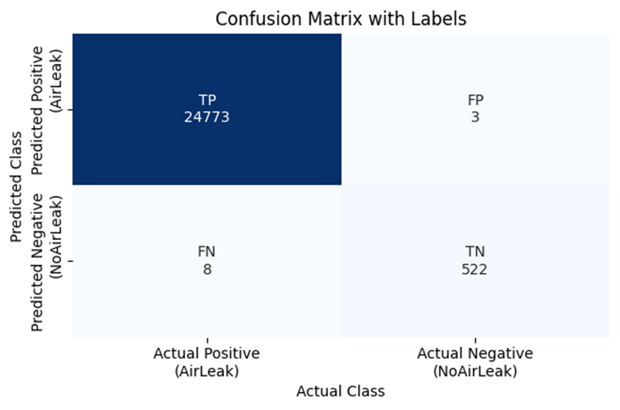
Figure 5.1. Confusion matrix for stacking ensemble model
- The model correctly predicted 24,773 instances of AirLeak, showcasing its strong ability to detect actual failure cases.
- It also correctly identified 522 instances of NoAirLeak, reflecting good recognition of normal operational states.
- Only 3 instances were incorrectly predicted as AirLeak when they were actually NoAirLeak. These are false alarms, but the count is extremely low.
- Similarly, only 8 instances of actual AirLeak were missed and classified as NoAirLeak. This is important in safety-critical systems, but the misclassification rate is very minimal compared to the overall data volume.
These results align well with the findings of our paper, which highlight the stacking model’s superior performance, achieving near-perfect values (all around 99.96%). Out of 25,306 instances, only 11 samples were misclassified, which equates to a misclassification rate of just 0.043%. This extremely low error rate reinforces the reliability of the stacking model for real-time applications in metro systems.
From a maintenance and safety standpoint, the stacking model minimized false negatives, ensuring that most failure events were detected, thereby reducing the risk of unanticipated breakdowns. At the same time, the low false positive rate prevented unnecessary maintenance, contributing to more efficient use of resources.
An analysis was conducted on ensemble machine learning, deep learning, and hybrid models for predicting the Remaining Useful Life (RUL) of trains, utilizing RMSE, R²-score, MSE, and MAE metrics, as detailed in Table 5.2.
Table 5.2. Remaining Useful Life (RUL) Regression Models
Models | RMSE | R2-score | MSE | MAE
Random Forest | 0.42 | 0.81 | 0.18 | 0.29
XGBoost | 0.43 | 0.80 | 0.19 | 0.32
Bagging | 0.42 | 0.81 | 0.18 | 0.29
Stacking | 0.42 | 0.81 | 0.18 | 0.30
CNN | 0.51 | 0.73 | 0.27 | 0.37
LSTM | 0.28 | 0.91 | 0.08 | 0.19
GRU | 0.28 | 0.91 | 0.08 | 0.18
TCN | 0.30 | 0.91 | 0.09 | 0.20
TCN-GRU | 0.26 | 0.92 | 0.07 | 0.19
Our regression models outperformed previous studies regarding RUL prediction in metro trains. However, outcomes may differ when these models are applied to other types of machinery. The models presented addressed essential research goals by developing a hybrid TCN-GRU model, which effectively lowered prediction errors while reducing training duration and preventing overfitting. Remarkably, the TCN model showed shorter training times compared to CNN, and the LSTM model was more efficient than GRU, while both TCN and GRU successfully managed overfitting.
Among the ensemble models, Random Forest, Bagging, and Stacking demonstrated comparable results with an RMSE (0.42), a R²-score (0.81), an MSE (0.18), and an MAE ranging from 0.29 to 0.30. XGBoost performed slightly less well, presenting an RMSE (0.43) and a R²-score (0.80).
In the realm of deep learning, both LSTM and GRU surpassed the ensemble methods, featuring an RMSE (0.28), a R²-score (0.91), and an MSE (0.08). GRU achieved the lowest MAE (0.18), showcasing its enhanced accuracy. The TCN model also exhibited strong results, achieving an RMSE (0.30), a R²-score (0.91), and an MAE close to 0.20.
With an RMSE of 0.26, an R2 score of 0.92, an MSE of 0.07, and an MAE of 0.19, the hybrid TCN-GRU model performed best overall. This demonstrates how TCN and GRU work together to improve accuracy and robustness. As seen in Figure 5.2., we may see a graph between the actual and anticipated testing data to see if these findings are accurate.
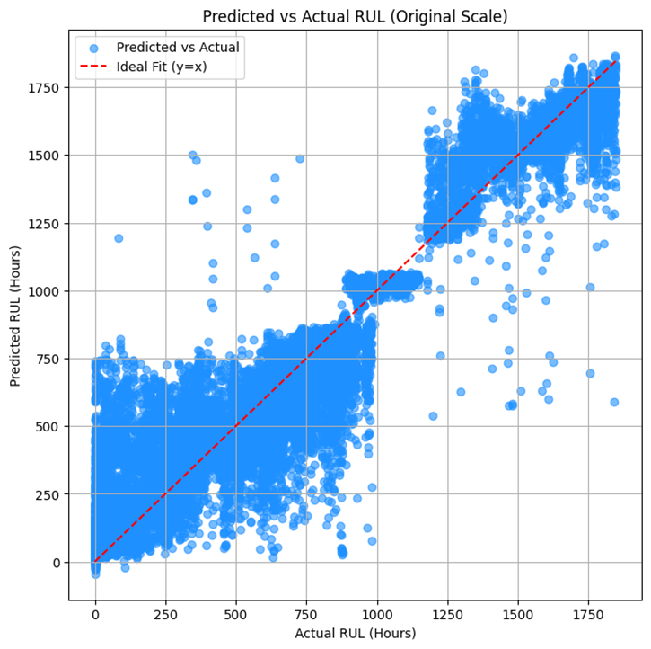
Figure 5.2. Actual RUL vs Predicted RUL Scatter plot
Figure 5.2 shows a scatter plot that compares the actual Remaining Useful Life (RUL) values from the test data with the ones predicted by the hybrid TCN-GRU model. Ideally, in a perfect prediction scenario, every point would sit right on the 45-degree line (where predicted equals actual). Interestingly, most of the points here are packed pretty tightly around that line, which is a good sign it suggests the model is doing a solid job of understanding the patterns in the time-series data. Looking closer at the plot, you can see that the predicted RUL values line up closely with the actual ones for the most part. This tight clustering points to a low overall prediction error and shows that the model is making consistent and accurate predictions a finding that’s backed up by the performance numbers in Table 5.2.
That said, not everything is perfect. There's a bit of spread, especially when the actual RUL values are higher. These scattered points show where the model’s predictions are slightly off either too low or too high. Here’s the breakdown:
- When a point falls below the diagonal, it means the model predicted less RUL than there actually was. So, it's being overly cautious. That’s not the worst-case scenario, but it could mean doing maintenance earlier than needed, which isn’t ideal for costs.
- If a point is above the line, it means the model overestimated how much life was left. That’s riskier it could lead to unexpected breakdowns if maintenance is delayed based on those predictions.
There are also a few outliers points that are way off from the rest. These are rare but expected, given how messy and unpredictable real-world sensor data can be, especially in complex systems like metro trains. These big errors could come from weird operational situations, sensor glitches, or just limits in what the model can handle. Either way, they’re worth investigating further to help improve the model’s reliability.
Overall, the TCN-GRU model shows that it can generalize well, even on data it hasn’t seen before. That means its predictions are not only accurate but also dependable enough to support real-world maintenance planning. The strong correlation between actual and predicted RUL suggests this model could genuinely help reduce unexpected failures and keep metro systems running more smoothly and safely.
To sum it up, both the GRU and the hybrid TCN-GRU models performed better than traditional ensemble methods. This shows how effective deep learning models can be when it comes to predicting RUL accurately in metro train systems.
And the best part? This kind of predictive power has real-world benefits:
- Early action: Maintenance teams can be alerted in advance, helping them fix things before they break and cutting down on surprise downtimes.
- Enhanced maintenance planning: Reliable RUL forecasts support improved scheduling and resource management.
- Increased safety and dependability: Reduced prediction errors enhance trust in automated systems within metro operations.
To summarize, the proposed hybrid model not only exhibits statistical superiority but also holds significant relevance for application in large-scale, safety-sensitive industrial systems.

5.2 XAI Models Interpretation and Explainability
In this research, we refrained from utilizing XAI techniques such as LIME and SHAP for deep learning and hybrid models due to the difficulties presented by time series data; however, there are algorithms like Integrated Gradients or DeepLIFT that could be used to elucidate the decisions of DL and hybrid models, which we could examine in future studies. Unlike data in tabular or image formats, time series data is sequential, meaning that each time point affects the ones that follow. Techniques like LIME, which alter individual features, can disrupt this sequence, potentially leading to erroneous explanations. Likewise, SHAP has difficulty capturing the intricate temporal relationships between prior and subsequent observations.
Nonetheless, we utilized LIME and SHAP on the top-performing ensemble machine learning model, XGBoost, for both failure classification and RUL prediction, primarily because of its reduced training time compared to other models.
While LIME delivers local interpretations, it does not provide insights into the overall contribution of features. This indicates that it can explain the rationale behind a specific prediction for an individual case (for example, the reasoning for predicting a metro train's failure at a particular time or estimating its RUL to be a certain number of hours).
Thus, LIME should be employed for both failure classification and RUL prediction when the main objective is to comprehend feature contributions for:
- A single, specific prediction: If a maintenance team wishes to understand why a specific train is predicted to have "No Failure" or why its RUL is reported as "X" hours, LIME can emphasize the local feature significance that drove that specific conclusion.
- Debugging or confirming individual model decisions: If a prediction appears contradictory or necessitates a thorough explanation for a specific case, LIME can assist in clarifying the local decision boundary of the model.
Consequently, if our aim is to grasp the overall significance of features across the entire dataset or to extract general actionable insights aimed at preventing future failures, SHAP is more suitable than LIME.
In the context of failure classification, although LIME offered local explanations for specific predictions, as illustrated in Figure 5.2.1, its emphasis on localized approximations did not provide a complete understanding of the overall feature significance across the dataset. For example, in the classification explanation provided by LIME, a prediction of "No Failure" with a probability of 1.00 is influenced by factors such as DV_pressure being less than -0.02, Oil_temperature being above 57.83, and TP2 ranging between -0.01 and -0.01.
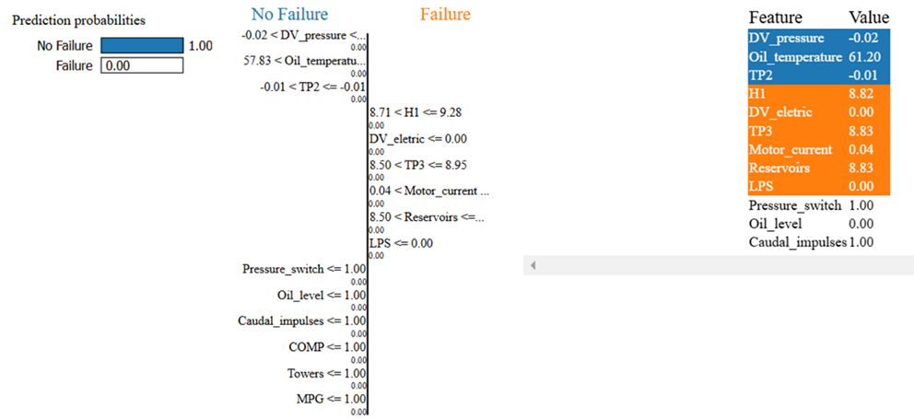
Figure 5.2.1. LIME algorithm for Classification model
In a similar vein, the local explanations provided by LIME for Remaining Useful Life (RUL) prediction, illustrated in Figure 5.2.2, highlighted the feature contributions for individual cases but fell short of offering a broader insight into how features impact the entire spectrum of RUL predictions. For instance, in the LIME explanation for RUL prediction, a predicted value of -0.90 is affected by negative contributions from Reservoirs (for instance, -0.76 < Reservoirs <= -0.24), TP2 (for example, -0.49 < TP2 <= -0.49), and TP3 (such as -0.76 < TP3 <= -0.04), along with positive contributions from H1 (for example, 0.39 < H1 <= 0.58).
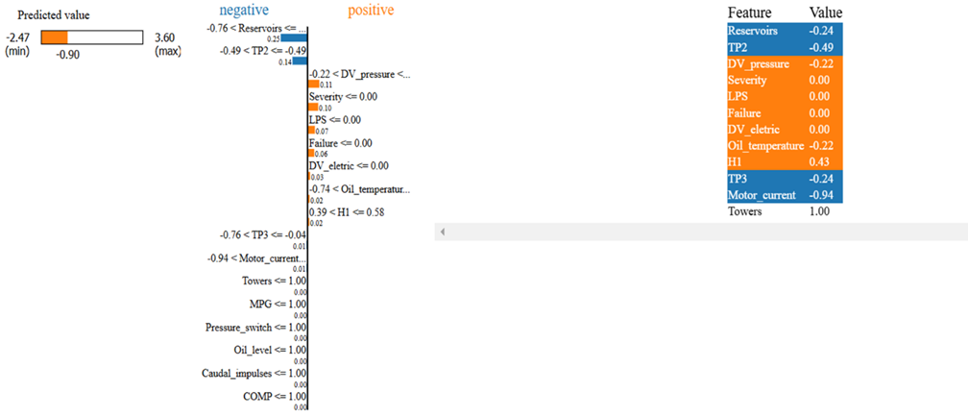
Figure 5.2.2. LIME algorithm for Regression model
On the other hand, SHAP provides global interpretability by indicating the overall impact of each feature. As a result, we showcased the SHAP outcomes to emphasize the significant features affecting model predictions in both classification and regression tasks.
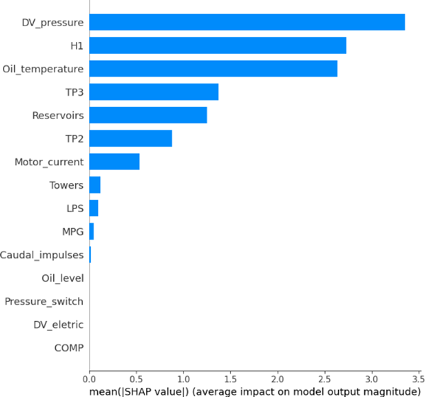
Figure 5.2.3. SHAP Global Interpretation for Ensemble Classification Model
As shown in Figure 5.2.3, factors such as DV_pressure, H1, Oil_temperature, TP3, Reservoirs, TP2, Motor_current, among others, exhibit the highest mean absolute SHAP values. This overall indicates that these factors are the most significant in forecasting failures (class 1) within the metro train air production system.
Presently, we identify which factors contribute to failure (class 1) predictions; however, to analyze and determine the potential threshold values for each feature beyond which the likelihood of failure rises sharply, we can utilize the same SHAP method, specifically the dependency plot function. This visualizes the relationship between the SHAP values for each feature (y-axis) and the actual feature values (x-axis).
To establish thresholds in classification with SHAP dependence plots, we should identify points where there's a notable change, fluctuation, or shift in the distribution of SHAP values as the feature value varies. Such shifts reveal points where the impact of the feature on the model's output (the prediction of failure or class 1) significantly alters. Additionally, when SHAP values transition from negative to positive, positive to negative, or exhibit a clear change in their magnitude or spread, it signifies a point where the feature's effect on class 1 prediction changes considerably. For instance, if SHAP values turn positive after a specific point, it suggests that feature values exceeding that threshold heighten the likelihood of failure. Conversely, if they switch to negative, it indicates a reduced likelihood.
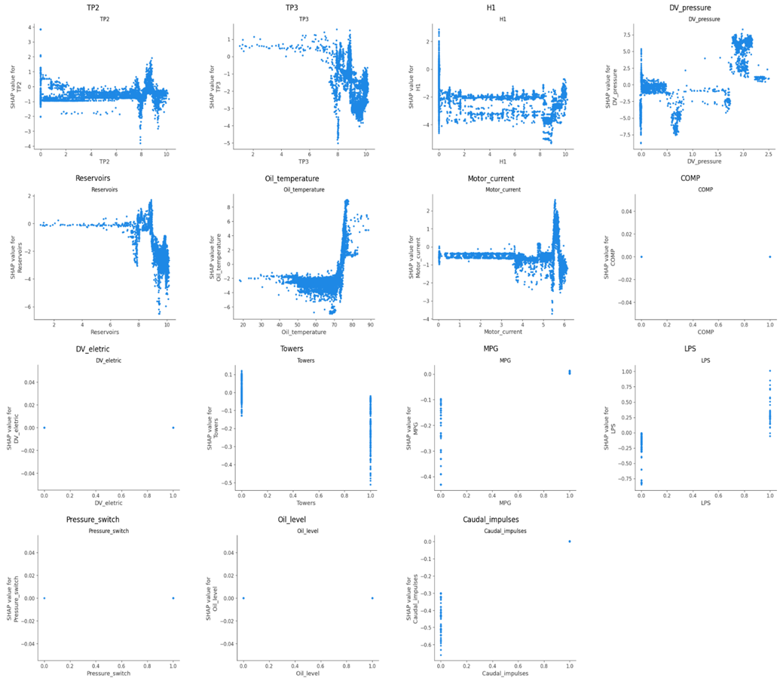
Figure 5.2.4. SHAP Dependence plot for each columns in ensemble classification model
Utilizing the previously mentioned threshold value method, we can examine Figure 5.2.4, which illustrates the dependency plot for the ensemble classification model, and identify the threshold values or ranges for each individual feature that leads to failure (class 1) predictions.
Table 5.2.1. Feature Thresholds and SHAP Interpretation in the Classification Model
Features name (Unit) | Threshold/ Threshold range values | SHAP dependence plot Interpretation and analysis
TP2 (bar) | 8.0 | Below 8.0 has minimal or negative impact; above 8.0 increases failure likelihood.
TP3 (bar) | 8.0 | Above 8.0 contributes to failure; below 8.0 reduces predicted failure.
H1 (bar) | 8.0 | Below 8.0 reduces failure likelihood; above 8.0 contributes to slight failure.
DV_pressure (bar) | 0.5 to 1.5 and greater | Low values have little impact; values greater than 1.5 sharply increase failure prediction.
Reservoirs (bar) | 7.5 | Below 7.5 has neutral to negative effect; above 7.5 contributes to failure.
Oil_temperature (°C) | 70 | Below 70 reduces failure risk; above 70 strongly increases failure prediction.
Motor_current (A) | 5.0 | Below 5.0 has weak impact; above 5.0 increases failure likelihood significantly.
COMP | Binary (0 or 1) | Minimal SHAP influence for both values; not an important feature.
DV_eletric | Binary (0 or 1) | SHAP values near zero for both states; negligible effect on model prediction.
Towers | Binary (0 or 1) | Value 1 reduces failure risk; value 0 has neutral to slight positive impact.
MPG | Binary (0 or 1) | Value 0 reduces failure likelihood; value 1 has minor or neutral effect.
LPS | Binary (0 or 1) | Value 1 increases failure risk; value 0 reduces it.
Pressure_switch | Binary (0 or 1) | Both states show SHAP values near zero; not a significant contributor.
Oil_level | Binary (0 or 1) | SHAP values close to zero regardless of value; minimal impact on prediction.
Caudal_impulses | Binary (0 or 1) | Value 0 strongly reduces failure prediction; value 1 has negligible effect.

According to the threshold values listed in Table 5.2.1 for each feature, train operators and maintenance personnel can utilize these thresholds in conjunction with SHAP interpretations to ensure that each parameter remains above the minimum threshold value, thus minimizing the chances of future failures (Class 1) in metro trains.
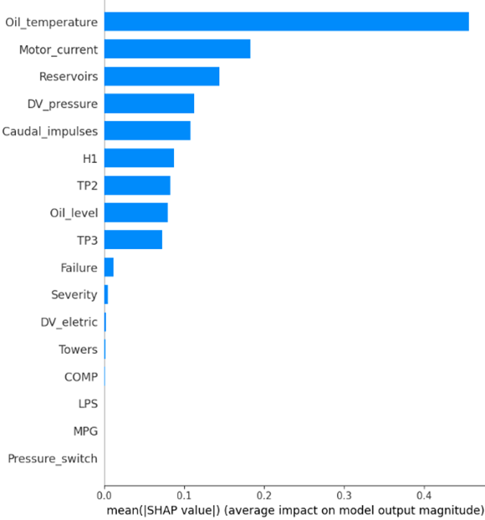
Figure 5.2.5. SHAP Global Interpretation for Ensemble Regression Model
As illustrated in Figure 5.2.5, parameters like Oil_temperature, Motor_current, Reservoirs, DV_pressure, Caudal_impulses, H1, TP2, among others, exhibit the highest mean absolute SHAP values. This indicates that these factors contribute to a decrease in the remaining useful life (RUL) of the metro train air production unit, reflecting a faster deterioration of the machine’s condition and an increased likelihood of imminent failure.
In summary, while we now understand that higher mean absolute SHAP values for certain parameters correlate with a decrease in the remaining life of the APU unit, which ultimately leads to failure, we can also analyze and determine the potential threshold values for each feature beyond which RUL declines. This can be accomplished using the same SHAP method and the dependency plot function, as we previously utilized in interpreting the classification model.
In a similar vein, we will apply the same methodology to identify thresholds in the regression (RUL prediction) scenario using SHAP dependence plots, much like we did in our classification model analysis. We should focus on identifying points where there is a notable shift, fluctuation, or variation in the distribution of SHAP values as the feature values change. These shifts or variations mark instances where a feature's impact on the model's output (the RUL prediction) significantly alters. Moreover, when SHAP values transition from negative to positive, positive to negative, or display a distinct change in their magnitude or spread, it highlights a juncture in which the feature's contribution to RUL prediction is evident. For instance, if SHAP values show fluctuations and turn positive after a specific threshold, it indicates that feature values above that threshold will decrease the remaining life of the APU unit, leading to failure. Conversely, if the values transition to negative after fluctuations, it suggests that feature values exceeding that threshold will enhance the remaining life of the APU unit, thereby extending its operational duration.
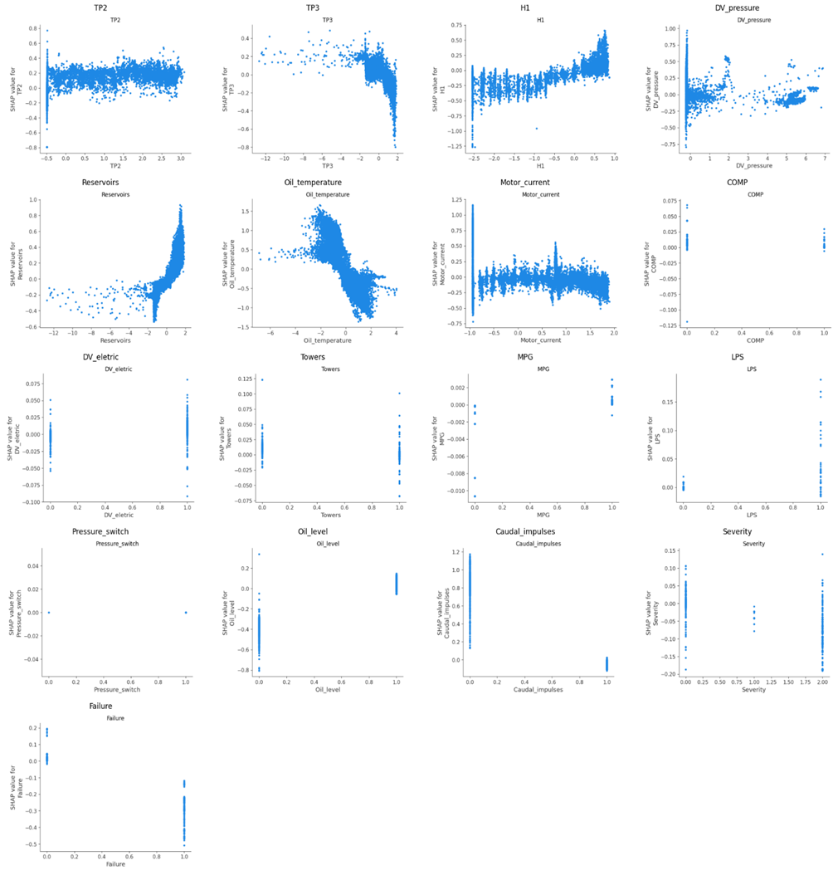
Figure 5.2.6. SHAP Dependence plot for each columns in ensemble regression model
Using the previously mentioned threshold value method for calculations, we can examine Figure 5.2.6, which illustrates the dependency plot for the ensemble regression model, and compile the threshold values or ranges for each individual feature that influences RUL predictions.
Table 5.2.2. Feature Thresholds and SHAP Interpretation in the Regression Model
Features name (Unit) | Threshold/ Threshold range values | SHAP dependence plot Interpretation and analysis
TP2 (bar) | No clear threshold (stable graph with positive shap value) | Highly variable impact in range [-0.04, 2.81]; positive and stable SHAP values beyond 2.81, suggesting increased RUL. This parameter will never decrease RUL.
TP3 (bar) | Approx. 9.29 | Positive influence below 9.29; significant negative SHAP values above 9.29, indicating RUL decreases with higher TP3.
H1 (bar) | Approx. 4.56 to 6.05 | Negative shap value fluctuate in range 0.09 to 4.56, indicating RUL decreases with higher H1 and after range 4.56 to 6.05, there is positive shap value fluctuation indicate RUL increases with higher H1.
DV_pressure (bar) | 0.58–0.75 | Positive SHAP values from 0.05 to ~0.75; mostly neutral/negative from 0.75–1.81; positive again beyond 1.81.
Reservoirs (bar) | 8.98 | SHAP values transition from negative to strongly positive around 8.98; higher values increase RUL.
Oil_temperature (°C) | 62.63-65.87 | Positive impact below 62.63; sharp drop beyond 65.87, lowest at ~62.34–75.57; higher temperature reduces RUL.
Motor_current (A) | 5.28 | Highly variable at low values; stable then negative trend beyond 5.28, indicating decreasing RUL.
COMP | Binary (0 or 1) | Value of 1 consistently increases RUL; 0 has mostly neutral to negative impact.
DV_eletric | Binary (0 or 1) | Value of 1 contributes positively; 0 is neutral to slightly negative.
Towers | Binary (0 or 1) | Value of 1 has slightly more positive impact than 0, which is mostly neutral.
MPG | Binary (0 or 1) | Minimal influence on RUL; both values near zero SHAP impact.
LPS | Binary (0 or 1) | Value of 1 has consistent positive contribution; 0 is neutral.
Pressure_switch | Binary (0 or 1) | No impact on RUL prediction; SHAP values are zero for both states.
Oil_level | Binary (0 or 1) | Value of 0 strongly decreases RUL; 1 is neutral to slightly positive.
Caudal_impulses | Binary (0 or 1) | 0 has strong positive impact; 1 shows neutral to slightly negative SHAP values.
Severity | Categorical (0, 1, 2) | Severity 1 increases RUL; Severity 0 and 2 reduces RUL.
Failure | Binary (0 or 1) | Failure = 1 sharply decreases RUL; 0 increases RUL (positive SHAP values).

Based on the threshold values outlined in Table 5.2.2 for each feature, train operators and maintenance teams can utilize these thresholds along with SHAP interpretations to ensure that each parameter remains above the minimum threshold value, thus enhancing the remaining life of metro trains.
Having scaled the dataset and trained an ensemble model for RUL prediction, along with interpreting the dependence plot of SHAP to ascertain threshold values, we now need to reverse the scaling of these thresholds using the original training data, as demonstrated in Table 5.2.2. We can apply the same scaling formula and feature indexing to compute the inverse scale for these threshold values for each feature.
Figures 5.2.3, 5.2.4, 5.2.5, 5.2.6, and Tables 5.2.1, 5.2.2 provide maintenance teams and train operators with the means to ensure that the features stay within the threshold values, which can be implemented as preventive measures to potentially reduce the frequency of failures and extend the lifespan, or remaining useful life (RUL), of metro trains.

5.3 Limitations of our study
Although this research offers an enhanced and interpretable framework for condition-based maintenance and Remaining Useful Life (RUL) estimation in metro train systems through ensemble and hybrid deep learning models, it is important to acknowledge several limitations to fully grasp the results and inform future research.
1. Narrow Focus on a Single Subsystem: The approach has been applied exclusively to the Air Production Unit (APU), which plays a vital role in braking and door functions. While this targeted focus allows for comprehensive analysis, it limits the broader applicability of the results. The thresholds, model behaviors, and performance metrics obtained from APU data may not necessarily apply to other subsystems or industrial contexts without additional validation and adaptation.
2. Reliance on a Single Dataset: This investigation is based entirely on the MetroPT-3 dataset gathered in Porto, Portugal. While it represents real-world data, the conclusions drawn may pertain specifically to the operational characteristics and context of the Porto metro system. The generalizability to other metro systems or regions remains uncertain and will necessitate validation with further datasets.
3. Lack of Real-Time Implementation: Though the proposed models exhibited robust predictive capabilities on historical data, the study did not address real-time deployment or streaming data analytics. This lack of consideration limits the practical application of these methods, as real-time performance is essential for successful predictive maintenance in active operational settings.
4. Challenges in Data Preprocessing and Practical Issues: Sensor data in the real world is frequently incomplete, inconsistent, or noisy. Additionally, acquiring proprietary or sensitive operational information poses further challenges. These factors complicate the preprocessing stage, which is crucial for ensuring accurate model training and inference. While the study acknowledges these limitations, it does not thoroughly address them, which may impact the overall strength of the proposed solution.
5. Absence of Cross-Validation Due to Computational Constraints and Temporal Dependencies: Cross-validation was not conducted due to the extensive nature of the time-dependent dataset and the significant computational resources required for repeatedly training deep and hybrid models like TCN-GRU. Furthermore, because the data reflects sequential temporal behavior, it was vital to preserve temporal order, rendering traditional cross-validation methods less appropriate.
6. Feature Scaling and SHAP Interpretability: To improve model accuracy, input features were standardized through normalization. However, the SHAP values and associated threshold interpretations were derived in this normalized context. Although it is feasible to invert the transformation, translating these values back to raw sensor readings for use by maintenance personnel is complex and may introduce approximation errors, thereby limiting operational interpretability.
7. XAI Constraints for Deep Learning Models: Explainable AI methods such as SHAP and LIME were only applied to ensemble models in this research. The transparency of deep learning models, particularly those managing time-dependent data like LSTM, GRU, and TCN-GRU, remains restricted. The study did not investigate alternative approaches like Integrated Gradients or others, which could potentially provide greater insight into model behavior. This restricts the clarity and reliability of these models in practical applications.
8. Manual Hyperparameter Selection: Hyperparameters were chosen manually instead of being optimized through systematic techniques such as grid search or random search. Although satisfactory outcomes were achieved, it is possible that more efficient or optimal configurations were overlooked, which might influence model performance and training efficiency.
9. Scalability and Training Duration: Due to their complex architecture and the substantial amount of data, some deep learning models utilized in this study require significant training time. This could impede their scalability and practicality for real-time or large-scale application in environments where quick retraining or deployment is critical.

Conclusion

This study put together a solid, easy-to-understand, and efficient system for condition-based maintenance, specifically built for metro trains with a spotlight on the Air Production Unit (APU). By combining traditional ensemble machine learning methods with a hybrid deep learning model (TCN-GRU), the research tackled some pretty big challenges head-on. These included dealing with imbalanced datasets, making sense of long time-series data, avoiding overfitting, reducing dependency on synthetic data, managing high computational loads, and working with limited labeled data.

The team used the MetroPT-3 dataset, which consists of real sensor readings from metro systems. They cleaned and processed the data carefully using downsampling techniques that kept over 90% of the original data’s variance. That made the dataset lighter and faster to work with, without sacrificing accuracy. What’s more, the ensemble models performed surprisingly well at classifying failures no synthetic oversampling needed. Among them, the stacking model stood out with a near-perfect classification accuracy of 99.96%, along with super low error rates. That kind of performance makes it a strong fit for safety-critical systems like metro trains.

On the prediction side, when it came to estimating Remaining Useful Life (RUL), the hybrid TCN-GRU model really delivered. It picked up on long-term patterns in the data and nailed the regression metrics, with an RMSE of 0.26 and an R² score of 0.92. That level of precision means maintenance teams can act earlier, avoid breakdowns, and keep things running smoothly.

To make the whole system more transparent, the study also brought in Explainable AI (XAI) tools like LIME and SHAP. These helped shine a light on how the ensemble models were making decisions both on a case-by-case basis and from a big-picture view. That’s incredibly useful for maintenance teams, helping them understand what’s going wrong and where to focus their efforts. While explaining deep learning models (especially ones working with time-series data) is still a bit tricky, this research opened the door for applying more advanced XAI in the future.

In the end, the framework offers a real-world, reliable, and understandable solution for predictive maintenance in metro systems. It hits that sweet spot between accuracy, speed, and usability. By working with real sensor data and focusing on both performance and interpretability, the proposed method can help reduce unexpected breakdowns, cut maintenance costs, improve safety, and keep metro services running more efficiently. All in all, it’s a meaningful step forward for smarter, more reliable maintenance strategies in complex, safety-focused industries.

Future Scope
While this study brings a lot of promising results to the table, there’s definitely still room to grow. Future research should look into some of the current limitations and find ways to make the framework even more practical, scalable, and widely usable. Here are a few directions worth exploring:

- Looking Beyond the APU: So far, the focus has been on the Air Production Unit (APU), but metro trains have many other critical subsystems like propulsion, braking, and door control that could also benefit from predictive maintenance. Expanding the model to cover these areas and testing it with data from different metro systems would help prove how adaptable and reliable the approach really is in varied real-world settings.

- Making It Real-Time Ready: For this framework to work in the real world, it needs to handle live data streams and make decisions on the fly. Developing real-time monitoring capabilities, including intuitive dashboards and automated alerts for maintenance crews, would turn this into a powerful tool that supports quicker responses, better planning, and improved safety.

- Smarter Resampling for Time-Series: Dealing with imbalanced time-series data is tricky especially when you want to preserve the natural flow and structure of the sequences. Future work could explore more advanced resampling methods that respect these time-based relationships while still reducing computational load.

- Faster, More Efficient Training: Training deep models can be time-consuming. To fix that, integrating automated hyperparameter tuning and tapping into hardware acceleration (like GPUs or TPUs) could significantly speed things up, making it much easier to retrain and scale the models when needed.

- Better Explainability for Deep Models: So far, explainable AI (XAI) tools like LIME and SHAP have helped explain how ensemble models make decisions but deep learning models are still a bit of a black box. Using advanced techniques like Integrated Gradients or Temporal SHAP could shed light on how these models interpret time-series data, giving maintenance teams more confidence in the predictions.

- Handling Concept Drift: Over time, conditions in metro systems can change whether it’s due to wear and tear, upgrades, or environmental shifts. Future research should look into how to detect and adapt to these changes (also known as concept drift) to keep models accurate and reliable in the long run.

- Taking It Beyond Metro Systems: What’s exciting is that all of these improvements could be useful in other industries too like manufacturing, energy, or aviation where predictive maintenance plays a huge role. These sectors also deal with massive time-dependent sensor data and have zero tolerance for failure.

References

[1] | T N. Davari, B. Veloso, R. P. Ribeiro, P. M. Pereira and J. Gama, "Predictive maintenance based on anomaly detection using deep learning for air production unit in the railway industry," 2021 IEEE 8th International Conference on Data Science and Advanced Analytics (DSAA), Porto, Portugal, 2021, pp. 1-10, doi: 10.1109/DSAA53316.2021.9564181.
[2] | O. N. NEAMAH and R. BAYIR, "Revolutionizing Fault Prediction in MetroPT Datasets: Enhanced Diagnosis and Efficient Failure Prediction through Innovative Data Refinement," 2024 Third International Conference on Power, Control and Computing Technologies (ICPC2T), Raipur, India, 2024, pp. 310-315, doi: 10.1109/ICPC2T60072.2024.10475088.
[3] | A. Shinde, M. Motiramani, P. Soni and A. Nanade, "Data-Driven Approach for Predictive Maintenance of Metro System," 2023 International Conference on Ambient Intelligence, Knowledge Informatics and Industrial Electronics (AIKIIE), Ballari, India, 2023, pp. 1-8, doi: 10.1109/AIKIIE60097.2023.10390300.
[4] | A. P. Hermawan, D. -S. Kim and J. -M. Lee, "Predictive Maintenance of Aircraft Engine using Deep Learning Technique," 2020 International Conference on Information and Communication Technology Convergence (ICTC), Jeju, Korea (South), 2020, pp. 1296-1298, doi: 10.1109/ICTC49870.2020.9289466.
[5] | J. Du, X. Gui, L. Song, S. Gao, C. Zhang and X. Li, "A method for predictive maintenance of mechanical equipment based on Transferable CNN-LSTM," 2022 Global Reliability and Prognostics and Health Management (PHM-Yantai), Yantai, China, 2022, pp. 1-7, doi: 10.1109/PHM-Yantai55411.2022.9941744.
[6] | G. Verma, J. Awatramani and N. Hasteer, "Implementing Deep Learning Model to Predict the Maintenance of an Elevator System," 2021 2nd International Conference for Emerging Technology (INCET), Belagavi, India, 2021, pp. 1-4, doi: 10.1109/INCET51464.2021.9456133.
[7] | S. Gawde, S. Patil, S. Kumar, P. Kamat, K. Kotecha and S. Alfarhood, "Explainable Predictive Maintenance of Rotating Machines Using LIME, SHAP, PDP, ICE," in IEEE Access, vol. 12, pp. 29345-29361, 2024, doi: 10.1109/ACCESS.2024.3367110.
[8] | D. Pradeep, B. V. Vardhan, S. Raiak, I. Muniraj, K. Elumalai and S. Chinnadurai, "Optimal Predictive Maintenance Technique for Manufacturing Semiconductors using Machine Learning," 2023 3rd International Conference on Intelligent Communication and Computational Techniques (ICCT), Jaipur, India, 2023, pp. 1-5, doi: 10.1109/ICCT56969.2023.10075658.
[9] | M. N. Al-Andoli, S. C. Tan, K. S. Sim, M. Seera and C. P. Lim, "A Parallel Ensemble Learning Model for Fault Detection and Diagnosis of Industrial Machinery," in IEEE Access, vol. 11, pp. 39866-39878, 2023, doi: 10.1109/ACCESS.2023.3267089.
[10] | T. Son Pham, D. Huy Nguyen and N. Duy Minh Phan, "An Interpretable Machine Learning Approach For Fault Classification in Bearing Systems," 2022 7th National Scientific Conference on Applying New Technology in Green Buildings (ATiGB), Da Nang, Vietnam, 2022, pp. 166-170, doi: 10.1109/ATiGB56486.2022.9984085.
[11] | K. T. Selvi, N. Praveena, K. Pratheksha, S. Ragunanthan and R. Thamilselvan, "Air Pressure System Failure Prediction and Classification in Scania Trucks using Machine Learning," 2022 Second International Conference on Artificial Intelligence and Smart Energy (ICAIS), Coimbatore, India, 2022, pp. 220-227, doi: 10.1109/ICAIS53314.2022.9742716.
[12] | E. Elahi, S. Kanwal and A. N. Asif, "A new Ensemble approach for Software Fault Prediction," 2020 17th International Bhurban Conference on Applied Sciences and Technology (IBCAST), Islamabad, Pakistan, 2020, pp. 407-412, doi: 10.1109/IBCAST47879.2020.9044596.
[13] | S. Bundasak and P. Wittayasirikul, "Predictive maintenance using AI for Motor health prediction system," 2022 International Electrical Engineering Congress (iEECON), Khon Kaen, Thailand, 2022, pp. 1-4, doi: 10.1109/iEECON53204.2022.9741620.
[14] | R. B. Mofidul, S. S. Alam, A. Chakma, B. Chung and Y. M. Jang, "Predictive Maintenance in Photovoltaic Systems Using Ensemble ML Empirical Analysis," 2023 Fourteenth International Conference on Ubiquitous and Future Networks (ICUFN), Paris, France, 2023, pp. 636-638, doi: 10.1109/ICUFN57995.2023.10199326.
[15] | T. Khan, K. Ahmad, J. Khan, I. Khan and N. Ahmad, "An Explainable Regression Framework for Predicting Remaining Useful Life of Machines," 2022 27th International Conference on Automation and Computing (ICAC), Bristol, United Kingdom, 2022, pp. 1-6, doi: 10.1109/ICAC55051.2022.9911162.
[16] | N. Davari, B. Veloso, R. Ribeiro, and J. Gama. "MetroPT-3 Dataset," UCI Machine Learning Repository, 2021. [Online]. Available: https://doi.org/10.24432/C5VW3R.

Certificate of Attending Conference / Journal Publication


Conference Publication:


Plagiarism Certificate
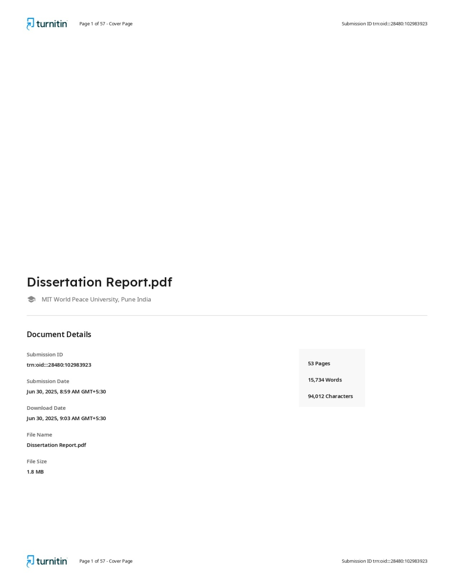


Certificate showing 7 % duplications

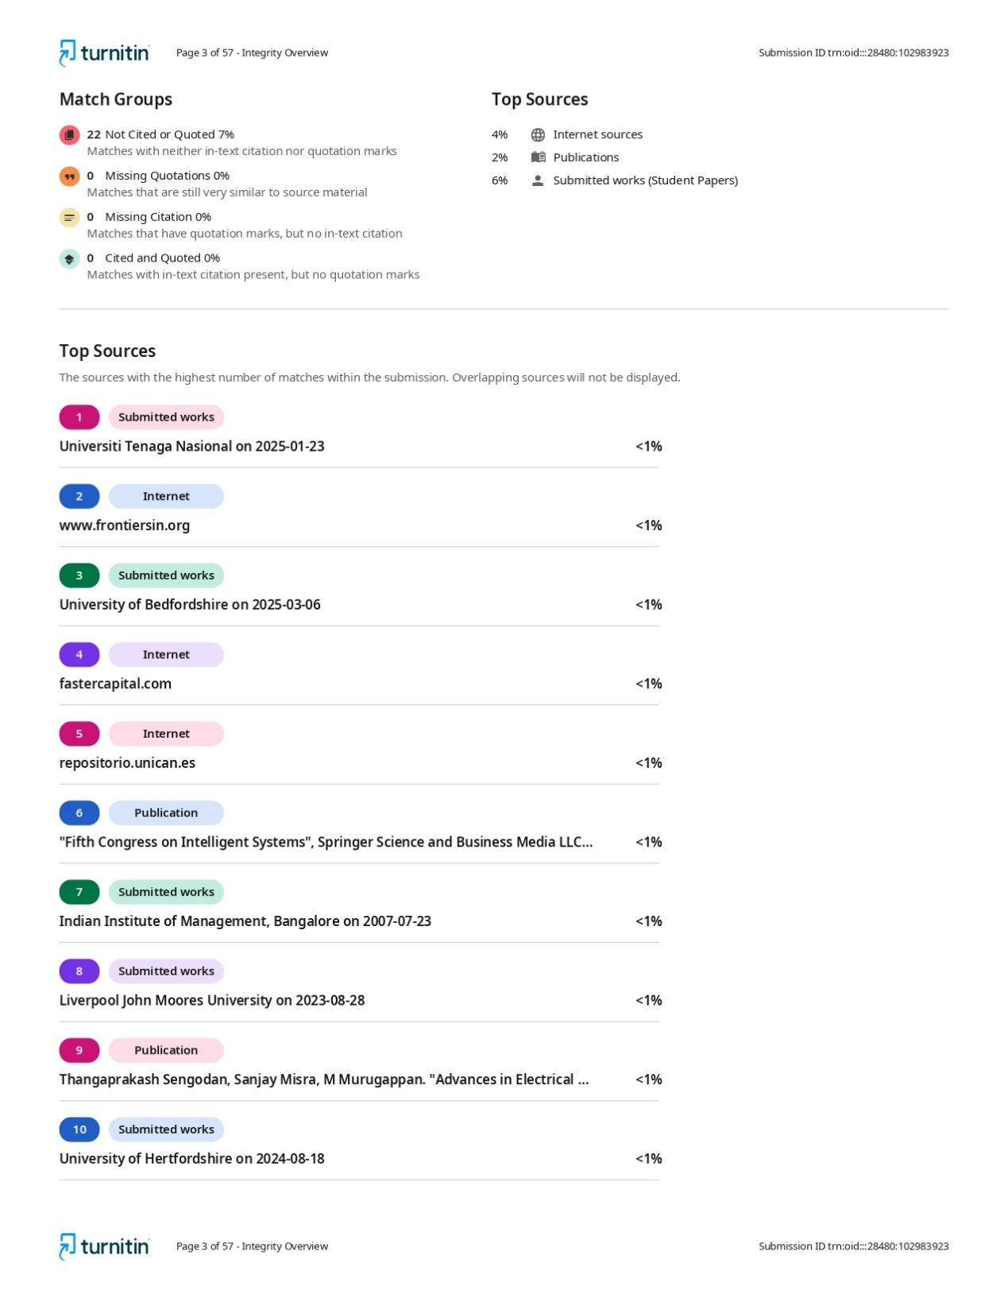
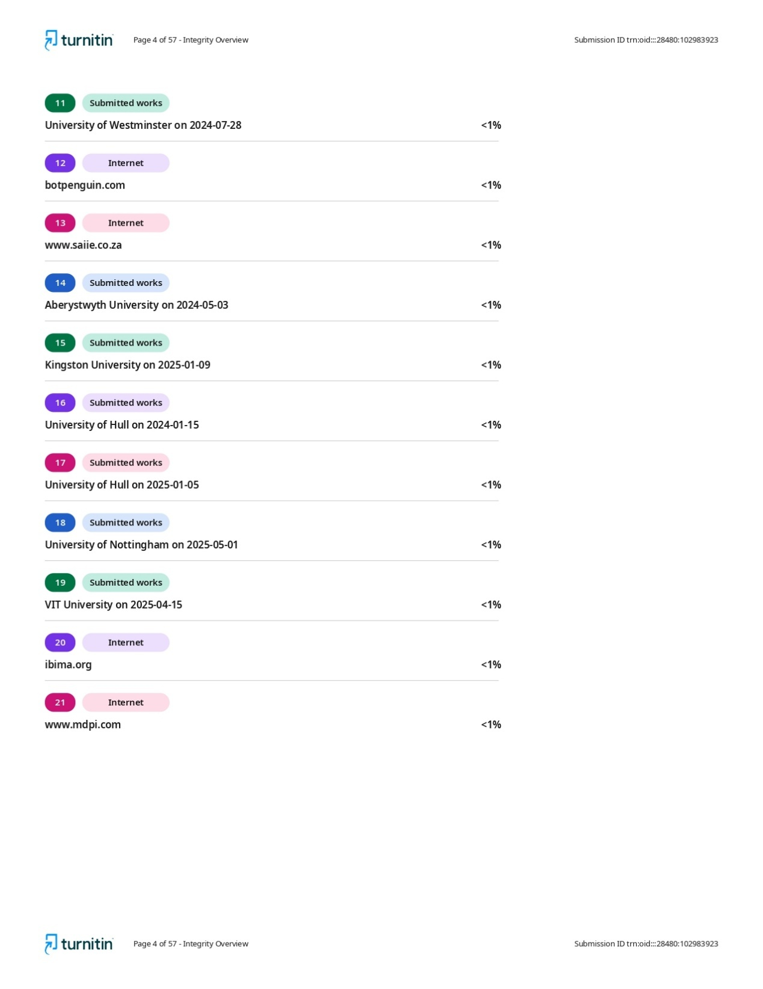

Appendix A
Explaining Condition-Based Maintenance for Metro Trains Using Ensemble ML with XAI and Hybrid Deep Learning Models
Submitted in partial fulfillment of the requirements of the degree of
(Master of Technology)
By
Aniket Singh
(Roll No: PA 06 Exam Seat No: 1032233536)
Supervisor (s):
Dr. Sarika Bobde

Department of Computer Engineering & Technology
DR. VISHWANATH KARAD MIT WORLD PEACE UNIVERSITY, PUNE.
[2024-25]
Appendix B
Approval Sheet
This thesis/dissertation/report entitled “Explaining Condition-Based Maintenance for Metro Trains Using Ensemble ML with XAI and Hybrid Deep Learning Models” by Aniket Singh is approved for the degree of M.Tech Computer Science and Engineering (CSE) with Specialization in Data Science and Analytics (DSA).

Examiners
_______________
_______________
_______________

Supervisor (s)
Dr. Sarika Bobde

Chairman
Dr. Preeti Kale

Date: ____________ Place: ___________

Appendix C
Declaration
I hereby declare that this submission is representing my ideas in my words. The ideas and words included from other sources are adequately cited. I also declare that I have followed all principles of academic honesty and integrity of the University. I have not misrepresented or fabricated or falsified any fact/data/idea in this submission. I understand that any violation will cause for disciplinary action against me by the University as per UGC notification 2018. I also understand that there will be a penal action against me, from the sources, which have thus not been properly cited or from whom proper permission has not been taken wherever needed. I hereby give undertaking that the document is prepared by me and document is my original work and free of any plagiarism in the limit prescribed by UGC.
Aniket Singh 1032233536
Name of the student PRN Number Signature with Date

I hereby declare that the work done by the above candidate under my supervision is free of plagiarism in the limit prescribed by UGC.

Dr. Sarika Bobde (Name and Signature of Supervisor)
I hereby declare that the document has been duly checked through a plagiarism detection tool approved by the university and Department Academic Integrity Panel.

Dr. Preeti Kale
Name and Signature
(Department Academic Integrity Panel
Member nominated by Program Director)
Date: __________

